FY 2007-2009 F&W Program Project Solicitation

Section 10. Narrative

This last section of your proposal is for text responses, explanations, and justifications that support the previous nine sections of the online form.

The Narrative is provided as a Word-compatible document (.doc suffix) that can be completed by inserting responses where indicated. The document will be submitted to CBFWA when completed.

To complete and return Section 10:
- View the instructions for this section at www.nwcouncil.org/fw/budget/2007/narrative.htm.
- Provide as much detail as you need in the spaces marked “(Replace this text with your response in paragraph form).” Do not leave parentheses around your response. Although there is no limit on the number of pages for the narrative section of the proposal, most narrative sections can provide sufficient detail in 10 pages, complex proposals in no more than 25 pages.
- You can insert tables, graphics or maps into this document. For help in adding graphics, contact Amy Langston at 503-229-0191 or amy.langston@cbfwa.org.
- This document will be viewed on the Internet. If you refer to online documents, include web addresses and use Word’s hyperlink tool to make those addresses active links in the document. Contact Amy for help.
- Please use Word’s spell-check tool before submitting this document.
- Save this document using your Proposal number or Project ID number (see Section 1) as the file name, and add an “n” to the end, like “198906201n.doc”.
- Return this document by browsing to your online proposal, choosing Section 10, then following the “Upload” instructions.

Project ID: 199306000

Title: Select Area Fisheries Enhancement Project

A. Abstract

As part of the 1993 Strategy for Salmon, the Northwest Power Planning Council (NPPC, currently Northwest Power and Conservation Council, NPCC) recommended terminal-fishing sites be developed to allow harvest of known hatchery production while minimizing incidental harvest of weak stocks. Beginning in 1991, listing of various ESU’s under the federal ESA complicated harvest management and severely limited execution of mixed-stock fisheries in the mainstem Columbia River. The Select Area Fisheries Evaluation (SAFE) Project was subsequently initiated by Bonneville Power Administration (BPA) in 1993 to mitigate fisheries by providing the opportunity to harvest locally-produced salmon stocks in off-channel areas of the Columbia River.

During 1993-1996, 25 potential sites were evaluated for rearing potential, capacity for fishers, access, water quality, and potential to impact non-local stocks, of which eight were selected for further study. Physicochemical and aquatic bio-monitoring surveys and extensive test fishing were conducted to establish baseline conditions, including if, and when non-local stocks use each area. Given available funding, five Select Area fishing areas were established and four currently exist including Youngs Bay, Tongue Point/South Channel, and Blind Slough/Knappa Slough in Oregon and Deep River in Washington.

Approximately 4,000,000 coho, spring, and fall chinook hatchery smolts are currently reared and released from SAFE net pens and associated hatcheries. Commercial and recreational fisheries have expanded substantially due to improved rearing strategies and increased releases as the project has progressed from research to implementation.

Continuation of this project will maintain the significant fisheries established in Select Areas, and allow for transition from the implementation to expansion phase, through increased production and efficiencies. Potential for additional expansion of the SAFE Project exists with the current infrastructure and is primarily constrained by available funding. For the proposed funding period, the sponsors Clatsop Economic Development Council (CEDC), ODFW and WDFW have incorporated multiple cost-efficiencies combined with a 1.2 million production increase to address concerns of the NPCC, Independent Scientific Review Panel (ISRP), and Independent Economic Analysis Board (IEAB).

B. Technical and/or scientific background
Background, History and Location of Problem

Decline in Columbia River Salmon
Historic natural production of salmon and steelhead in the Columbia River Basin prior to development has been estimated at 10-16 million fish compared to fewer than 2.5 million recently (F&W Program citation). Habitat degradation, hydro-power development, ocean and in-river over-harvest, and competition and genetic dilution from hatchery production have all played a role in this decline. Since the 1950s, the combined consequences of these factors have made the Columbia less and less habitable for anadromous fish, with hatchery production comprising more than 80 percent of commercially caught salmon in the river. (Center for Columbia River History)

Beginning in 1991, in addition to a continual decline in Columbia River Basin salmonid returns, the NMFS identified several populations of Columbia River Basin salmon and steelhead as evolutionarily significant units (ESUs) requiring protection under the federal Endangered Species Act (ESA). Under these provisions, harvest management of mainstem Columbia River commercial and recreational fisheries became increasingly complicated and severely limited execution of mixed-stock fisheries. Commercial and recreational access to harvestable surpluses of hatchery stocks due to the constraints imposed under the ESA was severely reduced.

Socio-Economic Impact

The number of active non-Indian commercial net fishers in the Columbia River has dramatically declined and with that decline has come measurable social and economic impacts to the region. Decreased fishing incomes, due to declines in salmon runs, price fluctuations, Endangered Species Act listings and allocation of more fish to the recreational sector have contributed to community health problems, which have increased along with poverty rates (Martin 2005). Fishing families who bring in incomes from other fisheries to an impoverished region feel under pressure to justify their emotional and financial commitment to the Columbia River and its environmental health when their incomes from that source are significantly eroded. (Martin 2005). More than local conditions, the emergence of salmon farming in both the northern and southern hemispheres has impacted the market for wild and hatchery salmon by displacing the latter from the world market by subsidized pen-reared fish (Mann, et al., revised 2005), although the demand for “wild-caught” salmon has increased recently.

Scientific and Technical Justification

The Select Area Fishery Evaluation (SAFE) Project has provided significant and valuable opportunities for both commercial and recreational fisheries to harvest strong, locally-produced stocks of hatchery salmon in off-channel areas of the Columbia River with minimal impacts to non-local stocks including species listed under the Endangered Species Act. Continuation of the SAFE Project will allow harvest opportunity until weak stocks have recovered to a point where they can sustain harvest. High harvest rates for target stocks and low impacts to listed ESUs are possible through in season adaptive management and are documented and supported by extensive monitoring of fisheries and stream surveys (Miller et al, 2000; North et al. 2004). The project has progressed from initial evaluation of sites, to expansion of all fisheries in Youngs Bay and establishment of winter, spring, and fall fisheries in other Select Area fishing sites. Methodologies for rearing and acclimating salmonids in net pens have been established resulting in high survival rates.

This proposal will allow for continuation of Select Area fisheries by providing funding for juvenile production, and fishery and habitat monitoring. Project staff have incorporated many cost-efficiencies into the project to allow for a juvenile production increase of 1.2 million fish with only a modest increase in required funding.

In keeping with the vision statement for the Lower Columbia River and Columbia River Estuary Subbasin Plan, this project utilizes “supportive hatchery and harvest practices…” while avoiding issues related to mixed-stock fisheries. The Bi-state Mainstem Lower Columbia River and Columbia River Estuary Subbasin plans identify the management of “Columbia River fisheries at sustainable levels, maintaining a viable population through adequate spawner abundance, and directing harvest away from depressed stocks” as Strategy 15 in the biological objectives of the recovery plan (p. 9 of the Executive Summary and p. 4-63 of the Management Plan). Continuation of the Select Area Project is specifically called for in Measure 37 (p. 4-63) of the Management Plan.

As outlined in the Management Plan Supplement (p. 5-36, 5-74, 5-111, 5-146, 5-180), the SAFE Project has demonstrated a high potential to contribute the following objectives: 1) supports a healthy Columbia basin, 2) maintains biological diversity, 3) maintains genetic integrity, and 4) increase run sizes or populations. The Select Area fisheries project is justified in Physical Objective 15 of the Management Plan Supplement (p. 5-86, 5-122, 5-156, 5-191).

The Select Area Fishery Evaluation project is also consistent with the objectives outlined in the Northwest Power Planning Council’s Final 2000 Columbia River Basin Fish and Wildlife Program (NWPP 2000). In the Council’s 2000 Multi-Species Approach for Decision Making, two of the overarching objectives are to provide “mitigation across the basin for the adverse effects to fish and wildlife caused by development and operation of the hydrosystem” and “sufficient populations of fish and wildlife for abundant opportunities for tribal trust and treaty right harvest and non-tribal harvest”. In its recommendation for artificial production review, the Council further states the harvest “hatcheries intended solely to produce fish for harvest to create a replacement for the lost or diminished harvest opportunities”, but cautions “the hatchery must be located and operated in a suitable manner that does not lead to adverse effects on other stocks through excessive straying or the excessive take of weak stocks in mixed stock fisheries”. The Council also warns that a harvest hatchery is of “little benefit if the majority of hatchery fish go uncaught because the potential harvest is restricted by another, much weaker stock. Because Select Area fisheries occur in off channel areas of the lower Columbia, the catch of non-local stocks including listed species is minimized. The acclimation of hatchery fish in net pens and subsequent liberal harvest of local hatchery stocks in Select Area fisheries further minimizes straying and the potential for the interaction with naturally spawning populations. The Council also recommends the identification of potential opportunity for a terminal fishery in every subbasin plan. The Select Area Fisheries Evaluation Project is one of, if not the only Bonneville Power Administration fish and wildlife program designed specifically to mitigate for lost harvest opportunity on the lower Columbia River.

C. Rationale and significance to regional programs
The Select Area Fishery Enhancement Project provides the opportunity for both commercial and recreational fishers to harvest strong, locally-produced stocks of hatchery salmon in off-channel areas of the Columbia River with minimal impacts to non-local stocks including species listed under the ESA. Due to the geographic separation of the sites and relatively low abundance of listed stocks, Select Areas provide meaningful commercial and recreational harvest opportunities that are not always possible in the mainstem Columbia River where various stocks commingle. While mitigation for development of the Columbia hydrosystem is focused on the preservation and recovery of depressed salmonids, the preservation of the fishery infrastructure is equally important if recovery is indeed defined by harvestable, naturally spawning populations. The SAFE Project was recommended in the recent Federal Columbia River Power System (FCRPS) Biological Opinion (BO) as a bridge to a time in the future when naturally spawning populations of salmon and steelhead again support commercial harvest. Fishing communities and their economies have been devastated by the collapse of Columbia River fish runs and curtailment of fisheries. The economic and social benefits of the SAFE project remain significant to affected non-Indian fishers and the sport and commercial fishing industries. Further reduction of non-Indian fisheries would only heighten the imbalance of conservation among industries that impact salmon throughout the basin. Biological objectives of the SAFE project are consistent with the Subbasin plans and goals outlined in the 2000 Fish and Wildlife Program.

The Bi-state Mainstem Lower Columbia River and Columbia River Estuary Subbasin plans identify the management of “Columbia River fisheries at sustainable levels, maintaining a viable population through adequate spawner abundance, and directing harvest away from depressed stocks” as Strategy 15 in the biological objectives of the recovery plan (p. 9 of the Executive Summary and p. 4-63 of the Management Plan).
While harvest reduction has the potential to benefit some species (e.g. fall chinook) more than others (e.g. chum), the Management Plan Supplement to the Bi-state Mainstem Lower Columbia River and Columbia River Estuary Subbasin plans recommend continuation of the SAFE Project because it has a “High” probability to contribute to the biological objectives in the recovery of chum (p. 5-36), fall chinook (pp. 5-54 and 5-74), coho (pp. 5-92 and 5-111), winter steelhead (pp. 5-128 and 5-146), spring chinook (pp. 5-162 and 5-179), and summer steelhead (pp. 5-198 and 5-217).
The Washington Lower Columbia River and Estuary Subbasin Plan recommends a strategy “preserving fishery opportunities focused on hatchery fish in a manner that does not adversely affect recovery efforts” (Section 6.6, pp. 6-32 and 6-35). The plan recommends “utilization of the Select Area off-channel sites” as action to minimize impacts to naturally spawning steelhead, coho, and spring chinook (Section 6.6, pp. 6-41, 6-42, and 6-43). For future monitoring and research, the Washington Estuary Subbasin Plan lists “evaluate innovative techniques (e.g. terminal fisheries and tangle nets) to improve access to harvestable stocks and reduce undesirable direct and indirect impacts to wild populations” (Section 7.8.5 p. 7-30). While these strategy recommendations are listed in the estuary and lower Columbia subbasin plans, conservation benefits from the Select Area fishery program apply to anadromous stocks in every subbasin of the Columbia River.
The Bi-State Mainstem Lower Columbia River and Columbia River Estuary Subbasin Plan prioritizes harvest management as Strategy 15 for achievement of the biological objectives in the conservation and recovery of depressed stocks of salmon and steelhead (p. ES-9). Strategy 15 states that Columbia River fisheries be managed “at sustainable levels, maintaining a viable population through adequate spawner abundance, and directing harvest away from depressed stocks” and ranks the benefit as “High” for the physical objective of protecting “genetic integrity and biological diversity and abundance of depressed stocks by directing the effort of commercial harvesters in the estuary to alternative, hatchery derived stocks” (p. 4-63). The Management Plan Supplement recommends the continuation of the Select Area Fisheries Project because it has a “High” probability to contribute to the biological objectives in the recovery of chum (p. 5-36), fall chinook (pp. 5-54 and 5-74), coho (pp. 5-92 and 5-111), winter steelhead (pp. 5-128 and 5-146), spring chinook (pp. 5-162 and 5-179), and summer steelhead (pp. 5-198 and 5-217).
The Washington Lower Columbia River and Estuary Subbasin Plan states that “salmon recovery is predicated on restoration of healthy, harvestable naturally spawning populations” and recommends “preserving fishery opportunities focused on hatchery fish” (p. 6-32).

New production of fish within the Columbia River Basin need to be evaluated and master plans prepared for National Environmental Policy Act (NEPA) review where none exist. Such a document was prepared by BPA for the Youngs Bay program in 1993 to meet the requirements of NEPA. A finding of “No Significant Impact” (FONSI) was issued by the U.S. Department of Energy (DOE) for the project. In 1995 a similar FONSI was issued for the expanded project. New production for use in terminal fisheries must be included in the aggregate annual smolt production ceiling for the Columbia River Basin of 197.4 million as specified in the NMFS proposed recovery plan. Use of Mitchell Act funded public hatcheries requires the approval of that agency. Also the Production Advisory Committee (PAC) established by the US v Oregon Columbia River Fish Management Plan must be informed to assure compliance and that allocation obligations are met. Lastly, the policies and procedures of the Integrated Hatchery Operations Team (IHOT) will be applied to new production terminal facilities.

The Independent Economic Analysis Board (IEAB) reviewed eight Columbia River Hatchery programs and reported their findings in the summer of 2002. One of those programs reviewed was the CEDC Fisheries Project. Although the data used to evaluate the cost per adult and cost per harvested adult have since improved, fish produced by this project then had better SARs and much higher harvest rates than any of the other projects studied. (IEAB Hatchery Report-Part 2).

The SAFE spring chinook program operates in accordance with the ODFW Fish Hatchery Management Policy (ODFW 2003), the Northwest Power and Conservation Council Annual Production Review Report (NPPC document 99-15), the Lower Columbia Salmon and Steelhead Recovery and Subbasin Plan (LCFRB 2004), and the Lower Columbia River and Estuary Bi-State Subbasin Plan (LCREP 2004). The program is also consistent with the ODFW Native Fish Conservation Policy (ODFW 2003).

Select Area fisheries are identified in, and consistent with the Biological Assessment concerning Columbia River treaty Indian and non-Indian fisheries as described in the recently adopted “2005-2007 Interim Management Agreement for upriver Chinook, sockeye, steelhead, coho, and white sturgeon” that was submitted to the NOAA Fisheries during the spring of 2005 with a subsequent Biological Opinion issued on May 9th, 2005.

Unique Aspects of the Select Area Fisheries Project

Availability of hatchery production for use in the terminal fisheries and the role of hatchery production relating to the harvest allocation obligations is an important factor in developing a successful terminal fishery. A substantial portion of the nearly 200 million smolts produced by hatcheries in the Columbia River Basin is dedicated to harvest mitigation. These priorities are developed by the fisheries co-managers to meet specific fish management objectives, such as mixed stock or terminal-area fisheries, supplementation of weak stocks, or in-river recreational or net fisheries” (BPA 1994). The inclusion of terminal net pen release sites attached to the harvest mitigation hatchery programs provides for much greater utilization of returning adults via the extensive harvest opportunities afforded by Select Area fisheries and thus helps to avoid large surpluses that occur in most years. Due to high value and an ability to harvest fish at a much higher rate than in the mainstem Columbia River, spring chinook released from the SAFE project contribute substantially to SAFE commercial and recreational fisheries. In fact, during 2000-2004 Select Area fisheries were able to harvest 3-8 times as many spring chinook per upriver impact than occurred in mainstem Columbia River commercial fisheries.

The SAFE project facilitates other opportunities to perform investigations into advances in understanding of the migration of fish in the estuary. NOAA Fisheries began an ongoing, collaborative study with SAFE in 2002 placing acclimation spring chinook into net pens at the Blind Slough site. Each year, six differentially tagged groups of 25,000 each are held for two weeks then released. Analysis of SARS and CWT recoveries has shown that releases in late April-early May survive much better than standard late March-early April releases of SAFE juveniles. Analysis of this study will be utilized by the SAFE Project to adjust release timing or changing from over-winter rearing to acclimation at that site to maximize survival.

Salmon smolts released from net pens in Youngs Bay have likely been subjected to substantial avian predation based on visual observations at time of release. To address this problem, the SAFE project conducted experimental releases of coho smolts during 2001-2004 to evaluate differences in adult survival and straying rates for fish reared and released from net pens within Youngs Bay (control) with fish reared in Youngs Bay but released in the mainstem Columbia River. Experimental release groups were drifted out of Youngs Bay during an ebb tide with navigation provided by three to four contracted commercial fishing vessels. Based on recovery of 3,656 coded-wire tags from 1999-2001 brood coho adults (2001-2003 release groups), the average survival of fish towed out of Youngs Bay prior to release (3.7%) was higher than for the control group (3.27%), although other release groups exhibited survival higher than the towed groups. Straying of towed fish (0.34%) was lower than all other release strategies including the control groups released from Youngs Bay (1.1%). Although towing results compared favorably to control releases, it is unclear if the difference is due to benefits of towing or because the control fish faired poorer than other rearing and release strategies. Because towed fish survived well and did not stray excessively, this release option warrants further evaluation with spring chinook. It may serve as a useful tool to circumvent avian predation in certain years or as a means of minimizing interaction and competition with wild salmonids in the Columbia River Estuary based on rapid outmigration rates observed for sonic-tagged spring chinook towed and released (see results for telemetry study below).

The unique approach of towing Select Area net pens (and entrained fish) to the mainstem Columbia River prior to release to avoid avian predation as described in North et. al. (2004) has also been applied to spring chinook releases at Deep River to avoid competitive interaction with native juvenile chum salmon. This potential conflict has caused problems with spring chinook releases in the past when holding net pen fish until all chum have vacated the area pushed releases back to June rather than the preferred April timing. This approach is supported by NOAA Fisheries staff as a way to limit the effect of SAFE hatchery production on listed chum salmon and could possible be applied in other sytems as needed.

Studies investigating the ability to influence travel behavior of salmon smolts were conducted in 2003 and 2004 with a Natural Solutions, a private company in Montana using a venturi system to create an artificial current in the net pens. The first trial was documented by United States Geophysical Survey center using under-water cameras. A companion study to determine if entrainment in the venturi would lead to scale loss or mortalities (either immediate or delayed) was performed by CEDC staff and Natural Solutions. Fifty thousand juveniles were passed through the venturi with no detectable losses. Four months later those fish showed no incidence of delayed mortality.
D. Relationships to other projects

The Select Area fisheries project is associated with several other programs in the Columbia River Basin. A summary of these projects and their tie with the SAFE Project are summarized below:

Relationship of gill ATPase and estuarine migration of net-pen reared spring chinook in the lower Columbia River (ODFW Restoration and Enhancement Project 03-022)

In 2003, the SAFE project partnered with Sea Resources, Salmon for All, ODFW, Oregon State University, and USFWS on this project to determine the migration rate and residency time of SAFE net-pen spring chinook and the correlation with gill Na⁺,K⁺-ATPase. Fieldwork was initiated by all parties in April 2004 and completed in 2005 although additional studies at other SAFE sites or with coho may continue. A total of 179 spring chinook smolts were fitted with acoustic transmitters, released, and tracked using mobile and fixed arrays. Understanding residency time of SAFE smolts in the lower Columbia River estuary will help determine the potential for impacts of SAFE releases on listed salmonids. Data analysis is ongoing. The project is currently managed by the Columbia River Estuary Taskforce (CREST).

Youngs Bay Terminal Fishery/Select Area Bright Chinook
(ODFW Restoration and Enhancement Project 03-005 and previous)

The ODFW Restoration and Enhancement Program has funded the majority of the SAFE select area bright fall chinook program, including annual operational expenses at Big Creek and North Fork hatcheries related to the maintaining the broodstock component of the SAB program, and partial funding for production in Youngs Bay net pens.

Coded wire tag – PSMFC (BPA Project 198201301)

The PSMFC coded-wire tag recovery project funds staff of several agencies to sample and recover coded-wire tags from regional commercial and recreational fisheries. A portion of the sampling effort under this project is used to assist with sampling of Select Area fisheries in Oregon. This project also funds the ODFW-Clackamas coded-wire tag recovery lab responsible for processing salmonid snouts collected from fisheries and reading the tags for subsequent inclusion in the PSMFC RMIS database.

Coded wire tag – ODFW (BPA Project 198201302)

The ODFW coded-wire tag project coordinates and conducts coded-wire tagging and mass-marking of most ODFW hatchery production, including production from Select Areas. Tagging and marking associated with the Select Area project occurs at Big Creek, Cascade, Gnat Creek, Klaskanine, Sandy, South Fork Klaskanine hatcheries, and at the Youngs Bay net pens. Tagging schedules are coordinated between CEDC and ODFW staff.

Coded wire tag – WDFW (BPA Project 198201304)

The WDFW coded-wire tag project coordinates and conducts coded-wire tagging and mass-marking of most WDFW hatchery production, including production from Select Areas. Tagging and marking associated with the Select Area project occurs at Grays River and Elochoman hatcheries.

ODFW funding for South Fork Klaskanine Hatchery (ODFW 52100 and previous)

The State of Oregon maintains a contract through ODFW for operational expenses at the CEDC South Fork Hatchery which produces fish for Select Area fisheries.

Timing of ocean entry and plume Evaluation (USACE Project W66QKZ20374368)

This study was initiated by NOAA Fisheries in 2002 to evaluate the effect of spring chinook release timing on ocean entry and other parameters. Annual releases of six unequally CWT-tagged spring chinook are acclimated and released from the Blind Slough Select Area rearing site. Adults return to the Blind Slough fishery and contribute to harvest. High harvest rates in the SAFE fishery allow for more complete recovery of CWT’s to assist with analyses. Recovery data is collected by SAFE project staff and provided to NOAA project sponsors. Results of the data are being used to modify release strategies to maximize survival of Select Area production.
E. Project history (for ongoing projects)

BPA Funding History
Project Number: 199306000
Years Funded by BPA: 1993-present (13 years)
Summary of BPA Funding:
Fiscal Year | Funding Level
1993 | $417,900
1994 | $535,500
1995 | 765,400
1996 | $785,900
1997 | $785,000
1998 | $900,000
1999 | $1,500,000
2000 | $1,400,000
2001 | $1,499,842
2002 | $1,613,344
2003 | $1,679,494
2004 | $1,655,741
2005 | $1,673,567

Project Reports and Technical Papers
Hirose, P., M. Miller, and J. Hill. 1996. Columbia River: Terminal Fisheries Research Report; 1994 annual report. Project 93-060 Annual Completion Report for the Bonneville Power Administration, Portland, Oregon. 151 pp.
Hirose, P., M. Miller, and J. Hill. 1998. Columbia River: Select Area Fishery Evaluation Project; 1995-1996 annual reports. Project 93-060 Annual Completion Report for the Bonneville Power Administration, Portland, Oregon. 194 pp.
Miller, M., J. North, P. Frazier, T. Jones, A. Dietrichs, and T. Miethe. 2002. Select Area Fishery Evaluation Project. 1997-2000 Annual Completion Report for Project #199206000 prepared for the Bonneville Power Administration, Portland, Oregon. 94 pp.
North, J., C. Rodriguez, M. Miller, J. Sewall, P. Frazier, S. Gray, T. Jones, A. Dietrichs, and T. Miethe. 2004. Select Area Fishery Evaluation Project, Final Completion Report for Project #199206000 prepared for the Bonneville Power Administration, Portland, Oregon. 143 pp.

History of the BPA Select Area Fisheries Project
ln 1976, Local fishermen and community members centered in Astoria, Oregon petitioned Oregon Department of Fish and Wildlife (ODFW) to allow them to rear and release coho juveniles for release into Youngs Bay in the hopes that a terminal fishery could be created. It was perceived that a fall fishery could be created in an off-channel site that would allow aggressive harvest of quality hatchery fish while doing no harm to fish migrating up the mainstem Columbia. This lead to development of the Clatsop Economic Development Council’s Fisheries Project (CEDC). Using early run hatchery stocks, the harvest was temporally and spatially isolated from other in-basin salmon stocks. Local businesses, the Port of Astoria, commercial fishers and processors supported the innovative CEDC program that was later augmented by State of Oregon appropriations and grants from the ODFW Restoration and Enhancement Board and Oregon Sea Grant. Federal agencies that provided direct funding and/or contributions to the project included U.S. Fish and Wildlife (Mitchell Act), National Marine Fisheries Service, Pacific States Marine Fisheries Commission, National Coastal Resources Institute, Comprehensive Economic Training Act, Pacific Northwest Regional Commission, and Economic Development Act.

Bonneville Power Administration (BPA) began initial financial support of the program in 1982 contracting directly with Clatsop County Economic Development Council. That support which represented less than 10% of CEDC project budget initially, grew to 60% by 1994.

In its 1993 Strategy for Salmon, the Northwest Power Planning Council (NPPC) recommended that terminal-fishing sites be identified and developed to harvest abundant fish stocks while minimizing the incidental harvest of weak stocks. The Council called on the Bonneville Power Administration (BPA) to "Fund a study to evaluate potential terminal fishery sites and opportunities. This study should include: general requirements for developing those sites (e.g., construction of acclimation/release facilities for hatchery smolts so that adult salmon would return to the area for harvest); the potential number of harvesters that might be accommodated; type of gear to be used; and other relevant information needed to determine the feasibility and magnitude of the program."

Beginning in 1993, BPA initiated the Columbia River Terminal Fisheries Project, a comprehensive program to investigate the feasibility of establishing and expanding terminal fisheries in Youngs Bay and other off-channel sites in the lower Columbia River (Hirose et al. 1996). This project is an extension of the existing hatchery system that utilizes existing hatchery facilities to spawn, hatch, and conduct initial rearing of juvenile salmonids for subsequent outplanting to net-pen facilities at each of the SAFE sites. This strategy capitalizes on documented improvements to growth and survival provided by net-pen culture pioneered by the CEDC Fisheries Project (Hirose et al. 1998).

During 1993-1994, 25 potential sites were evaluated for rearing potential, capacity for fishers, access, water quality, and potential to impact non-local stocks. Nine sites were considered to have high priority, with an overall ranking sufficient for immediate consideration: three on the Washington side and six on the Oregon shore. These sites were Grays Bay, Tongue Point basin, Big Creek, Blind Slough, Steamboat Slough, Svensen Slough, Clifton Channel, Cathlamet Channel and Wallace Slough.

Physicochemical and aquatic bio-monitoring surveys along with extensive test fishing was conducted at each potential site during 1994-1996 to establish baseline conditions, including if, when, and where non-local stocks use the each area. Given available funding and associated resources, five Select Area fishing areas were established and four currently exist including Youngs Bay, Tongue Point/South Channel, and Blind Slough/Knappa Slough in Oregon and Deep River in Washington.

Now referred to as the Select area Fisheries Evaluation (SAFE) Project (effective 1997), the sponsors are the Washington Department of Fish and Wildlife (WDFW), ODFW, and the CEDC Fisheries Project. At present 55 percent of CEDC’s funds are from BPA, while the remaining 45 percent are from local, state and other sources. The goal of the project was to determine the feasibility of creating and expanding known stock sport and commercial fisheries in the Columbia River Basin to allow harvest of strong anadromous salmonid stocks while providing greater protection to depressed stocks.

The project was conducted in three distinct stages: an initial research phase to investigate potential sites, salmon stocks, and methodologies (Hirose et al. 1998); a second phase of expansion in Youngs Bay and introduction into areas of greatest potential as shown from the initial stage; and a final phase of establishment of terminal fisheries at full capacity at all acceptable sites (Miller et al. 2002; North et al. 2004). The final phase of the SAFE project is intended to establish select area fisheries at full capacity at all acceptable sites through adaptive management strategies. No site is currently rearing all species of fish at full capacity and several potential sites have not been thoroughly evaluated. Although expansion has been constrained somewhat by stock availability, limitations on funding will control progression into this third phase of the program.

Project Results and Accomplishments

Major Accomplishments

1994 | Identified eight potential sites and selected four for development of net-pen rearing and harvest of salmonids in addition to the existing site at Youngs Bay. Built pens, installed pilings and access docks. Conducted initial water quality monitoring and test fishing at each site.
1995 | Implemented coho rearing and release at three of the new sites (Tongue Pt., Blind Slough, and Deep River). Implemented water quality and benthic monitoring at all sites, and continued 3-year test fishing. Significantly increased SAB fall chinook at Youngs Bay.
1996 | First adult coho harvest in new sites from experimental releases; Tongue Pt. 1,955; Blind Slough 2,301; and Deep River 2,240. Established fall chinook harvest opportunities in all sites. First spring chinook releases in Tongue Pt. and Blind Slough.
1997 | Significant spring chinook harvest in Youngs Bay (1,821). Relocated SAB fall chinook broodstock program to ODFW’s Klaskanine Hatchery to address straying concerns. Initiated winter-dormancy feeding experiments with spring chinook.
1998 | First spring chinook harvest in Tongue Pt. and Blind Slough. Added spring chinook rearing at Deep River. SAFE sport fisheries expand. SAFE commercial harvest: 2,258 spring chinook; 1,749 fall chinook; 24,134 coho. Minor impacts to listed ESU’s.
1999 | Expanded sport and commercial harvest opportunities in select areas. Implemented coho rearing/release at Steamboat Slough. SAFE commercial harvest: 1,955 spring chinook; 2,143 fall chinook; 22,954 coho. Minor impacts to listed ESU’s.
2000 | Initiated 3-year sub-surface feeding experiment with SAB fall chinook in Youngs Bay. All spring chinook mass marked. Increased SAFE commercial harvest: 6,496 spring chinook; 2,315 fall chinook; 61,745 coho. Upriver spring chinook impacts 0.013 percent.
2001 | Initiated 3-year avian-avoidance study in Youngs Bay by towing ~180,000 coho to mainstem Columbia at release. Increased spring chinook releases at Deep River. SAFE commercial harvest: 9,269 spring chinook; 3,098 fall chinook; 33,771 coho.
2002 | Added 150,000 acclimation spring chinook smolts at Blind Slough site through NOAA study (COE-funded). Initiated sub-surface feeding experiment with spring chinook. SAFE commercial harvest: 11,699 spring chinook; 8,570 fall chinook; 69,276 coho.
2003 | Initiated enhanced homing experiment with spring chinook at new MERTS site at Tongue Pt. utilizing chemical attractant (morpholine). SAFE commercial harvest: 7,820 spring chinook; 8,837 fall chinook; 114,352 coho. 0.2 percent impact to upriver spring chinook.
2004 | SAFE commercial harvest of 10,500 spring chinook, 12,642 fall chinook and 51,944 coho. SAFE sport harvest of spring chinook of 1,080 fish. 0.1 percent impact to upriver spring chinook from SAFE fisheries. Significant increase in spring chinook releases. Partnered on telemetry/ATpase study.
2005 | Impacts to upriver spring chinook from SAFE fisheries maintained at 0.1 percent. Completed 2nd year of spring chinook telemetry/ATPase study to determine outmigration rate. Initiated chum avoidance program with Deep River spring chinook.

Summary of Results

Following the extensive site selection and evaluation process described previously, experimental groups of coho (Oncorhynchus kisutch) were reared and released from the Tongue Point, Blind Slough, and Deep River sites in 1995 and Steamboat Slough in 1999 to determine each site's capability to successfully acclimate and imprint smolts based on recovery of coded-wire tags from returning adults. Coho were used during initial production years due to a surplus of juveniles and a shorter maturation cycle. Spring chinook (O. tshawytscha) were subsequently reared and released at Tongue Point, Blind Slough, and Deep River. Two stocks of fall chinook including upriver brights (URB) and select area brights (SAB; originally Rogue River stock) were evaluated at all Oregon sites. For all sites combined, annual SAFE-project smolt releases during 1993-2005 have ranged between 2.0-4.2 million coho, 0.4-1.8 million spring chinook, 0.1-0.6 million URB fall chinook, and 0.1-1.4 million SAB fall chinook.

Experimental fishing seasons were established in each site concurrent with initial adult returns of each species. Extensive sampling of the landed catch for each fishery has been and continues to be conducted to recover coded-wire tags applied previously to a representative component of each SAFE release and from any non-target stocks. Sampling of local hatchery returns, SAFE recreational fisheries, and spawning ground surveys in SAFE-site tributaries provides additional tag recovery data that is used to monitor survival, straying, and fishery contributions to determine if project objectives are being met. Fishing periods, gear, and area boundaries have been refined over time to minimize impacts to listed species.

Adult survival of select area spring chinook (1994-1998 broods) averaged 0.63 percent, similar to average survival rates for releases from Willamette River Basin hatcheries (0.59 percent). Select area coho smolt-to-adult survival rates (1993-1999 broods) ranged from 1.20–3.60 percent annually as compared to lower Columbia River hatcheries, which averaged 0.40-2.0 percent. Adult survival rates for select area bright fall chinook averaged 1.05 percent for brood stock releases at Klaskanine Hatchery (1995-2000 broods) and 0.86 percent for releases from net pens in Youngs Bay (1991-2000 broods). Average survival of upriver bright fall chinook (1994-1997 broods) was 0.11 percent.

Average stray rates for select area spring chinook were 0.5 percent for Blind Slough (1994-1999 broods); 3.6 percent for Youngs Bay (1994-1999); 20.8 percent for Tongue Point (1994-1998), and 26.7 percent for Deep River (1996-1997, 1999). Escapement of 1993-1999 brood year select area coho averaged 0.4 percent for Youngs Bay, 0.8 for Blind Slough, 1.8 for Tongue Point, 2.9 for Deep River, and 33.1 for Steamboat Slough (1997-1999 broods). Average stray rates for select area bright fall chinook were 13.8 percent for Big Creek Hatchery (1991-1995 broods), 0.7 percent for Klaskanine Hatchery (1995-2000 broods), and 1.9 percent for Youngs Bay net pens (1991-2000 broods). The stray rate for upriver bright fall chinook (1994-1997 broods) averaged 8.1 percent.

Based on these results several modifications to the original release programs were required. Upriver bright fall chinook releases at Tongue Point were discontinued due to unacceptable stray rates, and releases at Youngs Bay were curtailed because of poor returns. Releases of select area bright fall chinook from Tongue Point and Blind Slough were discontinued after 1997 due to poor survival and high stray rates, primarily to lower Columbia River tributaries. Select area bright fall chinook production was continued in Youngs Bay; however, the brood stock release and collection site was moved from Big Creek Hatchery to Klaskanine Hatchery in 1996 to reduce straying and maximize harvest of surplus adult returns. Production-level releases of spring chinook from Tongue Point were discontinued in 2000; pending results of 2003-2005 release trials from a new rearing site established in this area. Releases of coho from Steamboat Slough will be discontinued, but the site may continue to be used as a production facility.

During this reporting period, spring fisheries (mid-April through mid-June) targeting spring chinook were expanded in Youngs Bay based on increased releases, with new seasons established in Tongue Point, Blind Slough, and Deep River select areas beginning in 1998. Winter seasons were established during late-February through mid-March in Youngs Bay (1998) and Blind Slough (1999) to target early-returning spring chinook. Summer seasons (mid-June-July) have been adopted in Youngs Bay since 1999 to harvest SAB fall chinook. Due to these expanded fishing opportunities and additional releases, chinook harvest has increased steadily throughout the reporting period ranging from 155 fish harvested in 1995 to 11,699 fish landed in 2002. Landings of spring chinook in 2004 were 6,849 fish in Youngs Bay, 3,531 in Blind Slough, and 113 in Deep River. During 1992-2004, incidental harvest of white sturgeon (Acipenser transmontanus) in spring fisheries did not exceed 644 fish annually.

Fall commercial fisheries were established and monitored from early August through the end of October in Youngs Bay (1993-2003), and September-October in Tongue Point, Blind Slough, Deep River (1996-2003), and Steamboat Slough (2000-2003). The August portion of the season in Youngs Bay targets SAB fall chinook with the fisheries shifting to coho beginning in September. During 1996-2003, Youngs Bay harvest ranged from 1,225 to 5,157 fall chinook, and 13,649 to 94,279 coho. At the other sites annual coho harvest ranged from 26 to 15,598 fish during this period. In 2003, a record 117,133 coho were harvested in SAFE fisheries. Fish of SAFE origin dominated fall SAFE coho harvest during 1996-2002: Youngs Bay (87.1 percent), Deep River (85.9 percent), Blind Slough (81.6 percent), and Tongue Point (79.8 percent). The largest fall harvest of sturgeon in 1996-2003 SAFE fall fisheries was 334 fish, predominantly at Youngs Bay and Tongue Point.

Fisheries adopted during this reporting period resulted in a significant increase in interest in select area fisheries by both commercial and recreational user groups. The number of participating commercial vessels increased from 57 to 218 in spring fisheries and 96 to 192 in fall fisheries. Since recreational surveys were initiated in 1998, sport harvest has increased significantly especially for spring chinook and SAB fall chinook. The economic value of the fishery, as measured in ex-vessel dollars for commercial fisheries, and the non-market user value per fish landed in sport fisheries, increased from approximately $492,000 in 1996 to $3.3 million in 2003. The economic impact of SAFE salmonid production on personal incomes of families in lower Columbia River communities totaled $4.6 million in 2003.

One of the primary goals of this project was to maximize harvest of returning adults while minimizing catch of non-SAFE stocks. Coded-wire tag recoveries document extremely high harvest rates for all species: coho (98.3 percent), spring chinook (92.0 percent), select area bright fall chinook (96.4 percent), and upriver bright fall chinook (94.4 percent). As intended, the majority of the fish harvested in SAFE fisheries were of local origin although the contribution varied by site and year. For 1993-2003 winter-summer fisheries, SAFE releases comprised an average of 88.9 percent of the Blind Slough harvest (1998-2003), 80.1 percent of the Youngs Bay harvest (1993-2003), 74.6 percent of the Tongue Point harvest (1998-2003), and 69.2 percent of the Deep River harvest (2003). During 1996-2002, locally-produced coho contributed an average of 87.1 percent of the coho harvest in Youngs Bay, 85.9 percent in Deep River, 81.8 percent in Tongue Point, and 81.6 percent in Blind Slough. In Steamboat Slough, SAFE coho comprised an average of 57.8 percent of the landings during 2000-2002. Fall chinook harvest and stock composition varied considerably depending on the extent of releases at each site. During 1996-2002 Youngs Bay had an average annual harvest of over 1,934 fall chinook, with 97.0 percent originating from SAFE sites based on non-expanded CWT recoveries. Tongue Point and Blind Slough averaged 438 and 581 chinook, respectively, with SAFE stocks comprising 57.6 percent of the Tongue Point catch and 58.1 percent of the Blind Slough landings. In Deep River, 67.1 percent of the average annual harvest of 106 chinook were of SAFE origin.

The CEDC Fisheries portion of the SAFE project releases an average of 4.4 million smolts per year, which represents approximately 2.2 percent of the hatchery smolts produced in the Columbia River Basin. During 1993-2003, CEDC releases contributed an average of 38.3% of the total lower Columbia River non-indian commercial harvest with a range of 15.7-98.8%.

Another major goal of the SAFE project was to develop fisheries that provided greater protection for depressed and listed stocks. Impact rates in SAFE fisheries adopted during 1993-2000 were negligible. Impacts to upriver spring chinook increased during 2001-2003 (0.16 percent average) likely due to increased upriver run sizes but were maintained within management guidelines through in-season management. Annual landings of Snake River wild spring chinook in combined SAFE winter-summer fisheries during 1993-2003 ranged between 0-124 adults which represents a 0.00-0.20 percent impact rate. Impacts to wild Snake River fall chinook during 1997-2000 SAFE fall fisheries never exceeded 0.15 percent for all SAFE fisheries combined. Impacts during 2001-2003 fall fisheries are likely higher but final run sizes for this stock are not yet available.

In conjunction with rearing and releasing smolts into SAFE sites for the purpose of fishery development, many fish propagation studies were also initiated. Studies have focused on avian avoidance and predation, subsurface feeding, winter dormancy, rearing density, size at release, time of release, smolt condition and migration rates, and adult holding. Some study results have been incorporated into production strategies while others are incomplete pending final adult returns.

In addition to documenting results of net-pen released fish, all sites have been monitored for water quality to determine whether any change is occurring in local biochemical composition. Monthly measurements of water chemistry and macro invertebrate populations have been conducted before, during, and after each rearing period. To date the tendency has been for limited changes at some sites during the rearing period (November-April), with return to previous conditions during the recovery period (May-October).

Project Objectives and Evaluation Criteria

The goal of the Select Area Fisheries Enhancement Project (formerly Select Area Evaluation Project) is to provide commercial and recreational harvest opportunity for locally-produced hatchery stocks while minimizing impacts to listed salmonids. Specifically, the biological goals of the project include:
- Maximize Select Area production and fisheries
- Minimize the impact of Select Area fisheries on listed species
- Minimize the impact of Select area hatchery production on listed species

Evaluation criteria that will be used to measure progress toward project objectives include:
- Progress toward project release goals
- Progress toward increasing harvest in Select Area fisheries
- Progress toward improving smolt-to-adult survival rates
- Maintaining low impact rates on adult ESA-listed salmonids from incidental harvest in SAFE fisheries
- Minimizing straying of adult fish produced by the SAFE Project
- Monitoring the contribution of Select Area commercial harvest to total non-Indian commercial harvest in the Columbia River Basin
- Minimizing the potential for competitive interaction of SAFE juveniles with wild salmonids migrating through the Columbia River Estuary
- Minimize negative effects of Select Area production on the environment

Specific methodologies for how these eight criteria will be monitored area described below:

1. Release Goals

Moving the SAFE program from a focus on research to production has already begun. That process will continue with implementation of this proposal. The present production levels of coho and fall Chinook are below historical levels, which previously included annual releases of over five million “tule” fall Chinook in Youngs Bay. Present production has been limited by fish cultural factors, fluctuating SARs and management issues, all of which have been, or are being addressed. The combined BPA and ODFW funded production of SABs is permitted at 2.25 million, however, lack of sufficient gametes has limited production to an average of 1.5 million. We expect to reach the original intended production goal within this funding cycle.

Coho production also is down from historical levels for both Washington and Oregon sites. Replacement of the 200,000 production at Steamboat Slough is an immediate goal of this proposal. Those fish will be reared and released with the existing 200,000 at Deep River bringing that production to 400,000 during this funding cycle. BPA-funded releases of coho have been stable at 600,000 in Oregon, however, replacement of coho at the South Fork Hatchery with spring Chinook three years ago and the loss of the one million Mitchell Act funded coho smolts resulted in a net loss of 1.75 million coho. This proposal will regain 750,000 coho smolt production within this funding cycle.

Spring chinook production will remain at 850,000 at the Oregon sites and 350,000 at Deep River until additional funds are available. Different rearing strategies may be employed to improve SARs of spring chinook especially at the Blind Slough site. Funding for increased production of all three stocks is being sought by CEDC from non-BPA sources. Current, short-term, and long-term SAFE Project smolt production goals are presented in Table 10.E.1.

Table 10.E.1. Summary of current and proposed select area fisheries project smolt production.
Species | Site | Current | Short-term  (1-9 years) | Long-term  (≥10 years)
Spring Chinook | Youngs Bay | 450,000 | 950,000 | 950,000
 | Blind Slough | 450,000 ª | 450,000 | 450,000
 | Tongue Point | 100,000^{b} | 250,000 | 1,500,000
 | Deep River | 350,000 | 350,000 | 450,000
 |  | 1,350,000 | 2,000,000 | 3,350,000
Coho | Youngs Bay | 1,250,000 | 1,750,000 | 2,500,000
 | Blind Slough | 300,000 | 300,000 | 300,000
 | Tongue Point | 200,000 | 700,000 | 1,500,000
 | Deep River | 200,000 | 400,000 | 600,000
 |  | 1,950,000 | 3,150,000 | 4,900,000
Fall Chinook | Youngs Bay | ~1,500,000e | 2,250,000 | 3,250,000
 | Blind Slough | 0 | 0 | 0
 | Tongue Point | 0 | 0 | 0
 | Deep River | 0 | 0 | 0
 |  | ~1,500,000 | 2,250,000 | 3,250,000
All Species | All Sites | 4,800,000 | 7,400,000 | 11,500,000
ª Includes 150,000 smolt production funded by NOAA Fisheries
^{b} Experimental releases to evaluate homing of imprinted smolts at new MERTS site

2. Increased Harvest in SAFE Fisheries
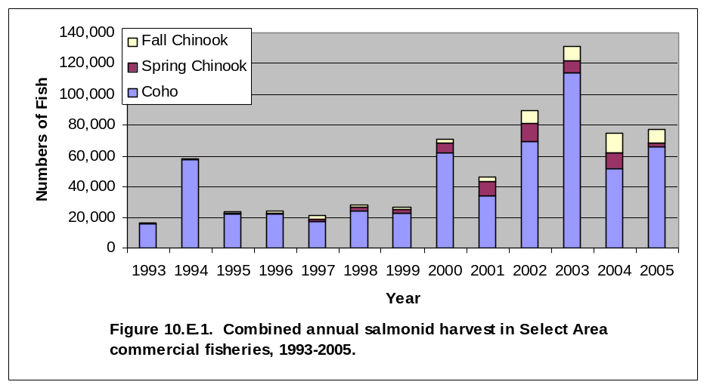
A primary evaluation criteria for the SAFE project is the number of commercially-harvested fish which remained fairly stable at ~25,000 fish landed annually from 1993-1999. Beginning in 2000, landings began to increase dramatically and peaked in 2003 when over 131,000 fish were landed in Select Areas (Figure 10.E.1). Harvest of winter and spring Chinook returns have grown over the span of the project increasing substantially since the production was shifted to Gnat Creek in 1996. Most fish are caught during the spring fishery with catches exceeding 11,000 fish in recent years.

The summer and fall fishery in Youngs Bay focuses on the SABs and early run coho. Since the initiation of SAFE fisheries, harvest at Youngs Bay has ranged from 1,225 to 4,289 fall chinook and 13,649 to 95,706 coho. The remaining sites only release coho with harvest ranging between 26 and 19,083 coho annually during 1996-2005. No more than three chum have been caught annually at any site. Commercial harvest in 2003 was the highest of the reporting period with 8,837 fall chinook and 114,352 coho landed for all sites combined. Incidental harvest of white sturgeon in select area fall fisheries has not exceeded 334 fish annually, with most harvest occurring in Youngs Bay and Tongue Point.
Recreational harvest in SAFE areas has increased significantly since creel surveys were initiated in 1998. Harvest of spring chinook increased from only 25 fish harvested in 1999 to an estimated 1,400 in 2004.
3. Survival Rates

Analysis of coded-wire tag recoveries from all regional fisheries, spawning grounds, and hatcheries as summarized on the RMIS database are evaluated repeatedly to track smolt-to-adult survival rates of Select Area releases. SARs are used as an evaluation criteria to determine the success of different species and site-specific release strategies. Results of these analyses are incorporated into rearing plans to maximize economic benefit of SAFE production. Average SARs for SAFE production are presented in Figures 10.E.2, 10.E.3, and 10.E.4 below:

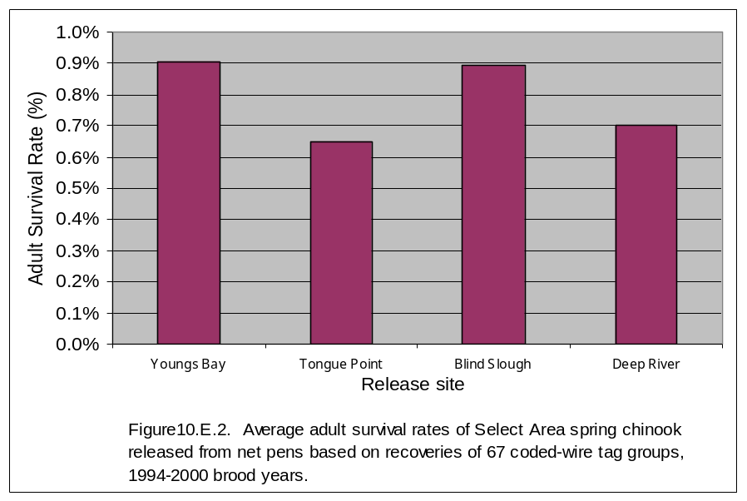

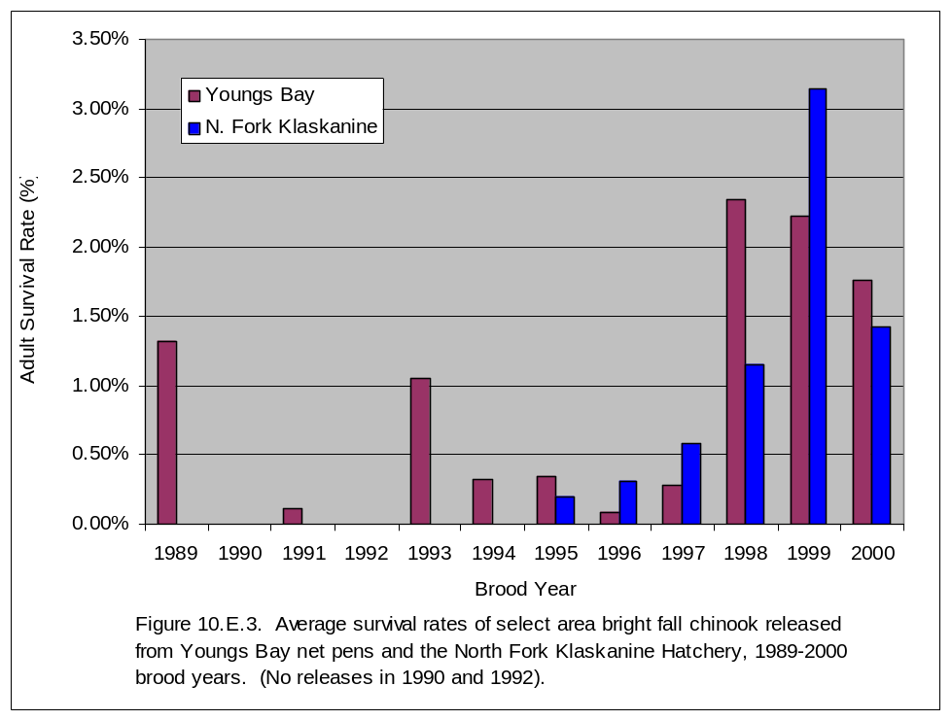

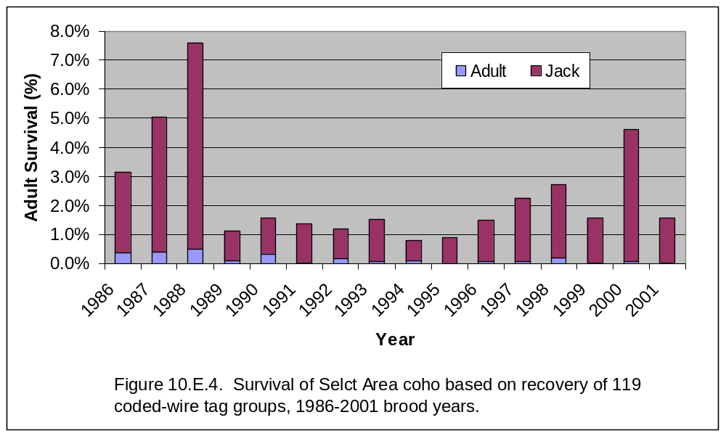

4. Fishery Impacts to Listed Salmonids

Although Select Area landings have generally increased since the inception of the program, impacts to listed species have not escalated proportionately (10.E.5). Impacts appear to be driven more by abundance of upriver stocks and river conditions especially during the winter and spring. From 1992-2000, combined annual upriver spring chinook impact rates in Youngs Bay winter-summer fisheries averaged 0.025%, or 12.5% of the SAFE management guideline of 0.20%. The average for 2001-2003 was 0.16%, due to unusually high mixing of non-local stocks in most of the Select Areas as a result of much improved upriver spring chinook returns. Due to high value and an ability to harvest fish at a much higher rate than in the mainstem Columbia River, spring chinook released from the SAFE project contribute substantially to SAFE commercial and recreational fisheries. In fact, during 2000-2004 Select Area fisheries were able to harvest 3-8 times as many spring chinook per upriver impact than occurred in mainstem Columbia River commercial fisheries.

This increase in impacts prompted fishery managers to rescind several adopted fishing periods during the peak of the season in 2003 to prevent the fishery from exceeding impact guidelines for non-local upriver stocks. The 2004 impact rate on upriver spring chinook in SAFE winter-summer fisheries was 0.10% (compared to a SAFE management guideline of 0.10%); similar to 2001 and about half of 2002-2003. The 2005 commercial fishery was also constrained due to an in-season downward adjustment of the upriver spring chinook run size and a maximum upriver spring chinook impact guideline of 0.10%. Actual impacts post-season were extremely low (0.012%) as a result of extremely conservative management. Impact rates on steelhead are assumed to be low due to mesh size restrictions that generally allow most steelhead to pass through nets, and results of extensive test fishing results conducted during the fishery development phase of the project which exhibited very low steelhead catch rates.

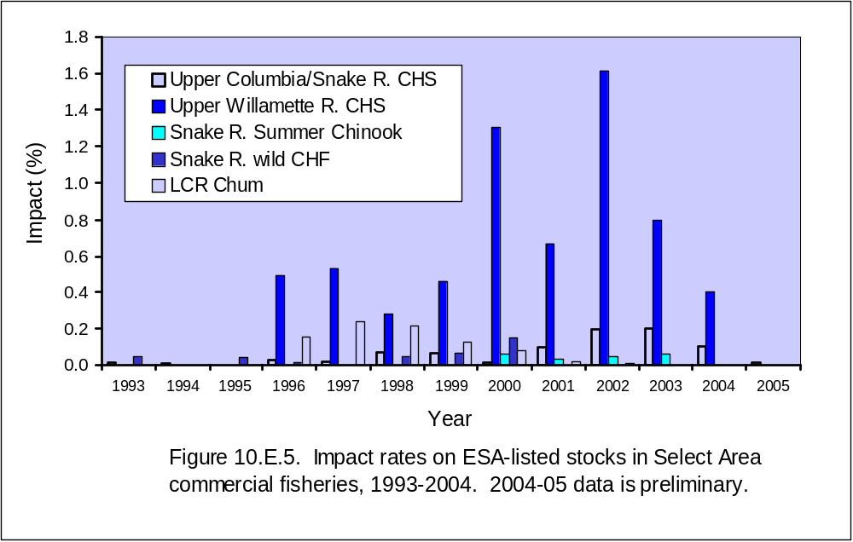

For all fall SAFE fisheries combined during 1993-2000, the impact rate to Snake River wild fall chinook ranged from 0.0-0.15%, and averaged 0.04%. Very few chum salmon are landed in select area fall fisheries, with impact rates not exceeding 0.24 % in any year during the 1996-2002

In recent years SAFE impacts have been managed as part of the overall impact allocation for main stem non-Indian fisheries. Impact rates in Select Areas are minor and generally of little consequence to the overall management of main stem fisheries. The states manage Select Area fisheries to minimize impacts to listed species. Impact rate guidelines for Select Area are not considered targets, but rather realistic guidelines within the parameters of protecting and recovering listed stocks necessary to maintain stable Select Area fisheries and allow for expansion as SAFE production increases.

Impacts to listed stocks resulting from Select Area fisheries are covered under two separate Biological Opinions (BO’s) issued for mainstem Columbia River spring and fall fisheries (NMFS 2003a; NMFS 2003b). Hatchery production by the SAFE Project is currently covered in a separate BO issued in 1998 (NMFS 1998). The current production BO is scheduled to be renewed concurrent with the ongoing Hatchery Genetic Management Plan (HGMP) process (Richard Turner-NOAA, personal communication). Existing and previous BO’s have found the project does not likely jeopardize the continued existence of listed salmonid stocks in the Columbia River Basin.

The project was initially operated under the Final Environmental Assessment (EA) of Youngs Bay Salmon Rearing and Release Program (BPA 1993). In May 1994, BPA prepared a Categorical Exclusion to perform research activities to identify and evaluate potential sites for expansion of this program. In 1995, the BPA completed an EA for the SAFE Project and issued a Finding of No Significant Impacts (FONSI). An additional FONSI issued in 1998 by BPA was found to be adequate in 2002 when BPA reinitiated ESA consultation with NOAA regarding SAFE Project activities. This EA and FONSI remain valid as long as project activities remain unchanged.

Extensive monitoring and evaluation activities occur throughout the year to assess stock status of salmon and steelhead returns and to monitor fishery impacts. The landed catch from all Select Area sport and commercial fisheries is sampled for biological information, including visual stock identification (VSI) for spring chinook, fin marks, coded wire tags (CWT’s) and scale samples. Landings for each Select Area site are sampled and calculated separately to account for variability in landings and species, stock and age composition for each fishery.

The landed catch in Select Area fisheries is monitored extensively to ensure adequate representation of the catch and to determine impacts to non-local stocks. Sampling includes collecting representative weight and length data by species, examining the catch for any external tags or marks and collecting visual stock identification (VSI) information. Scales and CWT’s are collected for age and stock composition analyses and to determine straying and survival rates. All snouts are delivered to tag recovery labs in Clackamas, Oregon or Olympia, Washington where the CWT is extracted and decoded. The resulting tag code is entered and verified on a mainframe computer. The CWT recovery data are summarized to estimate the number of CWT’s recovered for each tag code for each sampling program. Associated fishery/recovery and biological data collected when snouts are recovered, are entered into electronic databases, uploaded to the mainframe computer, and merged with corresponding CWT recovery data. Based on program specific sampling rates, individual tag recoveries are increased by an expansion factor to estimate the total number of a particular tag code estimated to be present in a given fishery. Data is then transferred to Pacific States Marine Fisheries Council (PSMFC) for posting on the Regional Mark Information System (RMIS) website for use by fishery managers in making in-season fishery management decisions.

Minimum target sampling rates are 20% of the landed catch by area and season; however, sampling rates are usually significantly higher (Table 10.E.2). Preliminary landings are summarized by statistical week based on phone surveys of buyers and processors. These landings are later confirmed with actual point-of-sale fish tickets. Average fish weight data from the sampled catch collected at buying stations is applied to species-specific landings (in pounds) by week to determine the number of fish landed by species for each Select Area. Coded-wire tag and VSI (spring chinook) data is summarized to determine stock compositions of fish landed in each Select Area fishery. Stock compositions are then applied to total landing estimates to produce stock-specific catch estimates. Stock-specific catch estimates for fisheries are monitored in conjunction with in-season run size updates to maintain fisheries within ESA guidelines.

Modified creel census programs are used to estimate sport catch in Select Areas. Effort is typically estimated based on a combination of either aerial counts; ground surveys of trailers, boats, or anglers; and volunteer log books, depending on the site. Catch rates are determined from data collected through interviews of anglers and volunteer log books. Effort counts are expanded to estimate total effort for each fishing site. Total catch by species is estimated by applying observed catch rates to estimates of effort by fishing area. The landed catch is sampled to collect biological information, recover CWT's and determine stock composition. Scales are collected to determine age structure of the landed catch and CWT, VSI (spring chinook), and/or fin-clip data are used to determine the stock composition and estimate the impacts to listed species.

The ODFW and the WDFW are responsible for sampling their respective Select Area fisheries to collect biological data, including CWT recoveries, and for summarizing data to estimate landed catch. The ODFW is responsible for fisheries in Youngs Bay, Tongue Point/South Channel and Blind Slough/Knappa Slough and WDFW is responsible for fisheries in Deep River and Steamboat Slough.

The joint WDFW/ODFW staff will continue to use VSI and CWT data to estimate impacts to listed species in Select Area fisheries. Total catch estimates will be produced using standard creel census and commercial fishery catch estimation techniques described earlier in this document. Visual Stock Identification and CWT data will be applied to catch estimates to develop individual stock composition estimates for sport and commercial fisheries in each Select Area. Stock compositions will be provided to the TAC for use in run reconstruction analyses to estimate contribution of listed stocks in fisheries. Each year, the TAC reviews both data and methodologies to improve the data base. Data corrections are incorporated on a continuous basis.

Fish run sizes and catches are carefully monitored in-season to ensure that catch does not exceed allowed guidelines. In-season catch estimates will be produced on a daily basis. Based on preseason forecasts or in-season updates produced by the TAC, impacts to listed species will be determined as needed (daily or weekly) to monitor impacts of ongoing fisheries. If the data suggests that impacts will exceed the impact guidelines, seasons will be modified as needed.

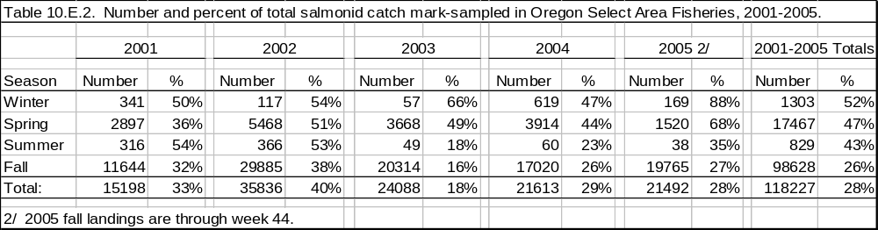

5. Minimizing Straying of SAFE Adult Returns

Stream Surveys and Hatchery Sampling
In addition to systematic stream surveys conducted each fall in lower Columbia River tributaries by various state agencies, SAFE project staff also conduct local stream surveys for a variety of reasons. Spawning ground surveys are conducted each fall in the Lewis and Clark, North and South Fork Klaskanine, and the Youngs rivers (all Youngs Bay tributaries) to estimate straying and escapement of adult SAB fall chinook. Each river is surveyed up to five times annually from late-September through October. Data collected includes redd counts and estimates of live and dead fish numbers. Carcasses are examined for sex, spawning success, fin marks, and also measured for length. Scales are collected to determine age composition. Snouts are collected from carcasses with appropriate fin-mark combinations with data incorporated into the RMIS system for estimating survival and stray rates. These surveys have documented the majority (90.0 percent) of fall chinook present in SAFE tributary streams in recent years were SAB stock, which occur at fairly high levels and exhibit spawning activity in area streams.

Additional spawning ground surveys have been conducted each winter in the South Fork Klaskanine since 1998 to determine the stock origin of a late run of fall chinook known to exist in the Klaskanine River drainage. It is possible this run is a remnant of Chetco and/or Trask stock releases from the North Fork Klaskanine Hatchery in 1975. Data collected during these surveys includes redd counts, live fish abundance, scale samples, and sex of adult mortalities. Muscle and organ tissues are also collected for ongoing genetic analysis.

Sampling of returning adults is conducted annually at several local hatcheries to collect biological data and recover coded-wire tags to determine adult escapement levels. Sampling of spring chinook occurs annually during April-June at Big Creek Hatchery concurrent with recycling of stray spring chinook back to the Blind Slough fishing site for additional harvest opportunities. Select area bright fall chinook are sampled at the North Fork Klaskanine Hatchery during October and November of each year concurrent with spawning activities. Coho and any stray spring chinook or SAB fall chinook returning to the South Fork Hatchery are sampled annually in October and November. Data collected includes sex, length, examination for external marks, and recovery of snouts containing coded-wire tags. All data is incorporated into the RMIS system for estimation of survival and stray rates.

Coded-Wire Tag Analyses
Survival and homing/straying rates are based on run reconstructions which are calculated using the Regional Mark Information System (RMIS) coded-wire tag database (www.rmis.org) managed by the PSMFC (www.psmfc.org). For each group all regional CWT recoveries, including hatchery and spawning ground escapement and harvest in fisheries, are combined to determine total smolt-to-adult survival rates (SARs). Survival rates of chinook salmon were calculated separately for sub-adults (jacks) and adults based on age-specific CWT recoveries. Escapement is categorized by area of recovery to separate detrimental straying from returns to natal streams. Release strategies are adjusted to maximize SARs and minimize straying whenever possible. Based on this data, several release programs initiated by the SAFE Project were discontinued or modified to limit impacts of straying.

6. Contribution of SAFE Production to Regional Fisheries

Harvest in Regional Fisheries
Since the inception of the SAFE project in 1993, a natural comparison has been to assess the relative contribution of commercial landings in SAFE fisheries to the total landings from the non-Indian commercial fishery on the mainstem Columbia River. Periods of low salmon abundance or restrictive management can constrain harvest on the mainstem, but SAFE fisheries can continue relatively unimpeded, resulting in larger contributions to the non-Indian commercial harvest. During 1993-2005, SAFE landings have comprised an average of 39.8% of the total salmon landings in the non-Indian commercial fishery for all species combined with a range of 15.7% in 2001 to 98.8% in 1995 (10.E.5). The average proportion of SAFE landings by species has been the highest for spring chinook (51.8%) followed by coho (43.5%) and fall chinook (18.3%). Although landings in both SAFE and mainstem fisheries fluctuate with the natural cycles of salmon abundance, SAFE fisheries are not constrained by weak stock management. Furthermore, because SAFE production goals do not require any fishery escapement, SAFE fisheries are liberalized to achieve the highest harvest rates possible.

Commercial harvest opportunity in Select Areas has been relatively stable compared to the mainstem, particularly in the late 1990’s when many Columbia salmon runs were at all time lows and some mainstem gill net salmon seasons were closed entirely. During 1994-1998, SAFE landings comprised over 80% of the total lower Columbia commercial harvest. Since 1999, the proportion of SAFE landings has decreased as adult returns of Columbia River salmon reached their highest levels of the post Bonneville era and commercial fishing opportunity on the mainstem increased. However, most salmon runs are again declining and the relative importance of the SAFE project will increase. During 2005, SAFE landings comprised 53% of the total non-Indian commercial landings on the mainstem, the highest catch proportion since 1998 (10.E.6).

During the recovery process of rebuilding depressed populations of Columbia River Basin salmon and steelhead, the SAFE project has maintained a viable commercial fishery in the lower Columbia River by providing significant, and in some years, most of the non-Indian commercial harvest. If the goal of salmon recovery is to rebuild depressed runs to harvestable levels, the SAFE project can bridge the gap between rebuilding and recovery and maintain the infrastructure needed by the same fishers who would ultimately harvest the resource once recovery is complete. As salmon recovery takes place, and if mainstem commercial fisheries can be restored, the importance and need for the SAFE project could diminish.

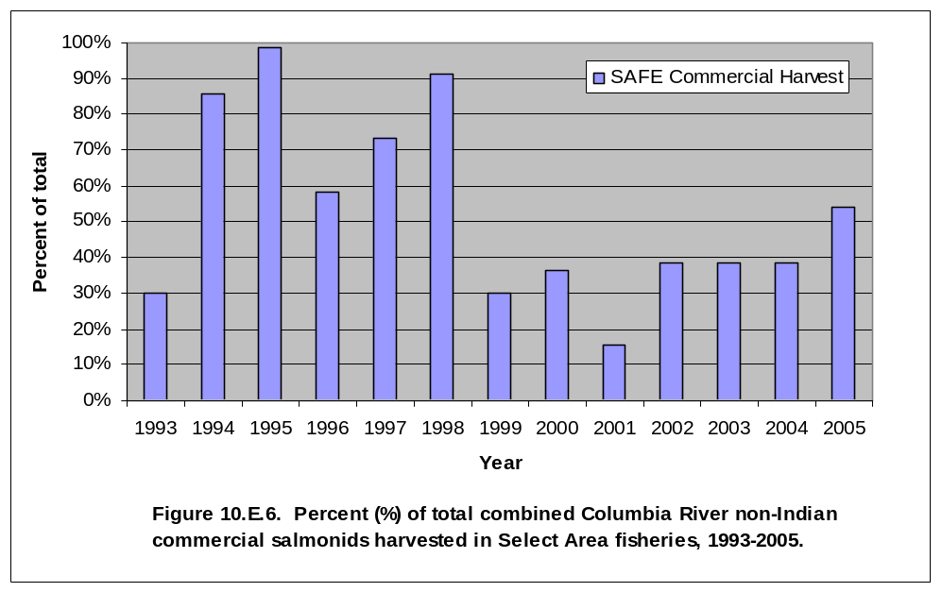

Salmonid production from SAFE facilities also provides significant contributions to other regional fisheries, both commercial and recreational. Fisheries benefiting from the SAFE project include ocean sport and commercial troll fisheries, Columbia River mainstem commercial and recreational fisheries (especially the “Buoy 10” fishery), and recreational fisheries occurring within select areas. Based on species-specific CWT recovery data for 1996-2003 return years, an average of 33.3 percent of the combined salmonid production from the SAFE project was harvested in fisheries other than the select area commercial segment.

Economic Benefits

In their review of the 1993-2004 Final Project Completion Report, the ISRP and IEAB expressed concerns about several aspects of the SAFE project and the report. In addition to requesting a thorough economic analysis of the SAFE Project, a more complete justification of data gathering, monitoring and evaluation methodologies and other features that were not fully supported by documentation was requested. Some of these concerns have been briefly addressed in this proposal, however, it is the contractors’ intent to comprehensively address each concerns in its 2005 Annual Report. That report was submitted to BPA in April of 2006. A formal response to the ISRP/IEAB review would have been submitted earlier but Council staff felt that the SAFE ISRP response and the economic analysis should be submitted together. Contracting issues delayed the start of the economic analysis, which therefore delayed formation of the response since many of the issues are intertwined.

One deliverable of the ten-year feasibility study is the estimation of probable project costs and benefits to the regional economy. The contractors provided a preliminary assessment and economic review for the program in October 2002. In addition to describing the production history and harvest numbers the report identified figures for ex-vessel values and expanded those numbers to identify approximate total personal income derived from the SAFE project using standard economic assumptions. Review by the IEAB identified the need for further in-depth analysis, including accounting for production and harvest costs to determine benefit:cost ratios of the SAFE Project.

Funding provided by BPA (via 2005 fiscal year SAFE Project savings) and ODFW has allowed for contracting with The Research Group to complete an in-depth economic analysis of the SAFE program with data that identifies the existing economic impact of the program and projections for future impacts. That analysis will be available in mid-to-late summer of 2006.

7. Minimizing Interaction

Telemetry
The issue of whether hatchery-reared salmon have a negative effect on wild stocks through competition, predation, disease transmission, and other mechanisms is a topic of continual debate (Myers and Horton 1982; Levings et al. 1986; Williams et al. 1998). Since SAFE project releases are significant, the project has received some criticism for not evaluating potential project effects. Wild juvenile salmonids using Youngs Bay, Tongue Point, Blind Slough, or the Columbia River estuary may be affected by releases of SAFE spring chinook even though only full-term smolts are released. We hypothesis these fish migrate rapidly through SAFE fishing sites and the lower Columbia River estuary with a minimum of ecological interaction with other species. Ledgerwood (1997) found radio-tagged spring chinook smolts released from Youngs Bay net pens out-migrated from Youngs Bay within one full tidal series and moved through the Columbia River estuary rapidly. Although it would be very difficult to quantify any adverse effects of SAFE production on wild salmonids, several actions have been undertaken to evaluate the potential for impacts and minimize the effects of SAFE project releases on wild juvenile salmon.

In 2003, the SAFE project partnered with Sea Resources, Salmon for All, ODFW, Oregon State University, and USFWS on an ODFW R&E funded project to determine the migration rate and residency time of SAFE net-pen spring chinook and the correlation with gill Na⁺,K⁺-ATPase. Fieldwork was initiated in April 2004 using 38 SAFE spring chinook smolts surgically-implanted with Vemco acoustic transmitters. An additional 141 fish were fitted with BPA-Batelle proprietary acoustic tags in April 2005. All fish were sampled for ATPase levels at time of tagging 1-d prior to release for subsequent correlation with outmigration rate. In 2004, approximately half the fish were released from the Yacht Club rearing site in Youngs Bay. The other half were transported to the mainstem Columbia River onboard a boat fitted with a flow-through live well and released. In 2005, approximately 75 smolts were released from the South Fork Hatchery, 31 from the Yacht Club net pen site, and 35 were towed to the mainstem Columbia River near Hammond prior to release. Both fixed and mobile antennas were used to track tagged fish. Fixed site arrays were established at various points including the confluence of Youngs and Klaskanine rivers (2005), Youngs Bay mouth (2004-05), the mainstem Columbia (2005), and the Columbia River mouth (2004). Data was downloaded weekly.

Preliminary results corroborate the rapid emigration rates documented by Ledgerwood (1997), with average travel time of 11.5 and 48.7 hours from Youngs Bay net pens to the mouth of the Columbia River in 2004 and 2005, respectively (personal communication; Robert Warren; Sea Resources and Columbia River Estuary Study Taskforce (CREST)). Results of this work will be presented in a project summary report to the R&E Board and in the 2006 SAFE Final Report following completion of data analysis.

Understanding residency time of SAFE smolts in the lower Columbia River estuary will help determine the potential for impacts of SAFE releases on listed salmonids. If residency times of SAFE smolts are minimal, the potential for significant negative impacts on other salmonids is reduced. Correlation of out-migration rates with ATPase levels will hopefully provide a tool that can be used to time releases when smolts are most likely to migrate directly to the ocean environment; thus minimizing potential impacts on native stocks during their early life history stages.

ATPase-CWT Release Trials
Beginning in 2002, project staff began a longer-term project of collecting representative tissue samples for gill Na⁺,K⁺-ATPase analysis from one annual release of coho, SAB fall chinook and spring chinook to determine levels of smoltification and the effect on adult survival based on subsequent CWT recoveries from returning adult fish. This data, combined with the telemetry results mentioned above, will help refine release guidelines that optimize survival of SAFE production and minimize impacts with other salmonids.

8. Documenting Environmental Effects

Water Quality Program
With the initiation of the SAFE project came the need to monitor impacts of net-pen rearing at net-pen sites. Limited water quality monitoring was conducted in Columbia River pen rearing sites in the past (Hirose et al. 1998), leaving the project with few guides for designing a monitoring program. Beginning in 1994 environmental monitoring was initiated at all existing and planned net-pen sites. The design exceeded all known state and federal requirements at the time. Monitoring has continued through the 2005 season.

1) The SAFE Project Environmental Monitoring Program was designed to assess the environmental suitability of water bodies being considered for fish rearing and to monitor water quality parameters annually during each production cycle to document their continued suitability. In order to monitor the ongoing suitability of the environment for the rearing of salmon at the various SAFE facilities, instruments are deployed at each site every month for a 24-hour period. These instruments record temperature, dissolved oxygen, pH, turbidity and specific conductance. The instrument probes are placed about two meters below the water surface between the net pens. The water bodies that have multiple net-pen facilities such as Youngs Bay and Deep River, are only monitored at one location.

All of the physicochemical parameters measured have been within the healthy tolerance range of the salmon being reared in the net pens by this project. Only the summer temperatures occasionally reach levels that may be stressful to salmon, but these occur during months when fish are usually not being held

2) In order to monitor the impact of the fish rearing activities on the benthic macro invertebrate populations at the impact station under the net pens and at the perimeter stations at the boundaries of the mixing zones, sediment samples are collected from these areas and from reference stations well outside of the area influenced by the fish rearing activities. Animals (macroinvertebrates) are picked from these samples, preserved, identified and counted. Characteristics of the benthic populations at the impact stations and the perimeter stations are compared with those at the reference stations to look for differences that could be attributed to the fish rearing activities.

The overall impact has been a minor change in macroinvertebrate populations during the rearing period (November-April) with returns to baseline levels by the beginning of the next rearing season.

9. Project Funding History

Prior to the initiation of the feasibility study launched in 1993, BPA began investing in the Youngs Bay terminal fishery project with substantial infrastructure purchases and support for other costs. By 1993 BPA had invested $280,000 in the CEDC Fisheries Project. The project had by that time received funding totaling nearly $2 million from a variety of local, state and federal sources. Oregon State provided a direct biennial appropriation for the operation of the South Fork Hatchery. Eyed eggs and or fingerlings from State hatcheries were provided at no cost to the program. Salmon for All persuaded local fishers to assess themselves a 5% fee on fish harvested in Youngs Bay and the fish buyers agreed to match that amount. Grants from diverse organizations, agencies and local governments were included in the early funding. Other in-kind support for the project included pathogen exams by ODFW, tagging and trucking of fish on various occasions, and equipment sharing.

On-going funding and in-kind support continues from both ODFW and WDFW. Both states provide gametes, usually eyed eggs, and logistical support for the program. In-kind SAFE Project contributions include 920,000 eyed spring chinook eggs for the Gnat Creek Hatchery, 1.725 million fingerlings and/or pre-smolts from Mitchell Act facilities in Oregon, and 400,000 eyed spring chinook eggs from two WDFW hatcheries.

Oregon Restoration and Enhancement (R&E) Board has funded a majority of the SAB program since 1991 providing annual operation funds for Big Creek and North Fork Hatchery operations associated with the brood stock program and for a portion of the grow out in the net pens in Youngs Bay. The R&E also underwrote feed costs for acclimating coho received from Eagle Creek Hatchery.

Total investment into the SAFE and pre-SAFE program by BPA is approximately $15.4 million, while non-BPA funding over that same period totals just under $4 million excluding in-kind contributions.

10. Project Re-Orientation Efficiencies

The contractors have concluded that with the main focus of the project moving more to production, use of personnel needs to change. Adequate benthic data and water quality information has been acquired to allow for the project to reduce staff previously assigned exclusively to this function. The water quality specialist position is being eliminated. Other seasonal staff positions in the Washington portion will be consolidated, effectively reducing staffing by another two FTE. In FY 2008 another 0.75 FTE in project management will be eliminated and consolidation of functions realized. Re-deployment of ODFW and CEDC staff to more efficiently cover fish cultural activities will better utilize available human resources. Gnat Creek Hatchery staff will assume the primary role of feeding net-pen fish at the Blind Slough site, which is nearby the hatchery. This will free up CEDC staff to assist in fish cultural support at the Klaskanine Hatchery, which is close to the South Fork Klaskanine facility. Other ODFW staff will have duties re-assigned to better meet the needs of the Klaskanine Hatchery, while still covering their sampling, surveying and data collection duties.

Three tag codes will be eliminated for the present unless and until specific research projects are initiated that require release trials. Consolidation of the SAB program with CEDC at the South Fork Hatchery and the Youngs Bay net pens will further reduce program costs.

All these efficiencies will make it possible for production increases of 1.25 million smolts at Deep River, Klaskanine and South Fork facilities without the need for significant funding increases.

F. Proposal biological objectives, work elements, and methods

All objectives address Strategy 15 of the Lower Columbia River Subbasin Plan, which states that Columbia River fisheries be managed “at sustainable levels, maintaining a viable population through adequate spawner abundance, and directing harvest away from depressed stocks” and ranks the benefit as “high” for the physical objective of protecting “genetic integrity and biological diversity and abundance of depressed stocks by directing the effort of commercial harvesters in the estuary to alternative, hatchery derived stocks” (p. 4-63).

Table 10.F.1. Summary of Select Area Enhancement Project biological objectives, work elements, and methods for 2007-2009.
Biological Objective
 | Work Element
 |  | Work Element Title | Methods
A. Maximize Select Area Production and Fisheries
 | 1. Produce Hatchery Fish
 |  | a. Spring Chinook | Conduct all fish propagation activities at Gnat Creek Hatchery associated with production of 2.55 million spring chinook from egg to smolt. ODFW
 |  | a. Spring Chinook | Perform all activities associated with over-winter rearing, acclimation and release of 2,550,000 spring chinook smolts at Youngs Bay, Blind Slough, Tongue Pt. MERTS and John Day net-pen sites. CEDC
 |  | a. Spring Chinook | Conduct all fish propagation activities at Grays River Hatchery associated with production of 350,000 spring chinook from egg to smolt.
 |  | b. Early stock coho | Perform all activities associated with over-winter rearing and release of 1.8 million early stock Lower Columbia River coho at Youngs Bay and Tongue Pt. MERTS net-pen sites. CEDC
 |  | b. Early stock coho | Conduct all fish propagation activities at Klaskanine Hatchery associated with production of 1.5 million coho from egg to smolt. ODFW
 |  | b. Early stock coho | Conduct all fish propagation activities at Grays River Hatchery associated with production of 550,000 coho from egg to smolt.
 |  | c. Select Area bright fall chinook | Perform all activities associated with producing 2 million SAB fall chinook smolts at Youngs Bay net pens. CEDC
 | 2. Mark/tag Animals
 |  | a. Mass-mark and CWT spring chinook | Mass mark (adipose) all 350,000 spring chinook released in this task and produce two CWT groups per year. WDFW
 |  | a. Mass-mark and CWT spring chinook | Mass mark 100% of all Gnat Creek hatchery spring chinook with adipose fin clips and tag four groups of 25,000 fish each with Coded Wire Tags for Blind Slough, Tongue Point, the John Day River and Youngs Bay .
 |  | b. Mass-mark and CWT coho | Mass mark (adipose) all 400,000 coho released in this task and produce two CWT groups per year. WDFW
 |  | b. Mass-mark and CWT coho | Mass mark (adipose) 100 percent and coded-wire tag representative groups of coho released at all Oregon sites
 |  | c. Mass-mark and CWT SAB fall chinook | Mass mark 100 percent all Select Area Bright fall chinook with left ventral fin clips. Mark and tag one group of 25,000 fish with adipose fin clips and coded-wire tags for Youngs Bay net-pen releases. CEDC/ODFW
 | 3. Trap,Collect,Hold,Transport Fish
 |  | a. Collect SAB fall chinook | Collect fish with live capture (tangle net) gear in upper Youngs Bay, sort into net pens, hold until maturation, and spawn. ODFW
 | 4. Analyze /Interpret Data
 |  | a. Monitor SAFE fisheries assessment contributions | Review fish tickets from select area fisheries to determine level of fishermen and processor participation and contribution. CEDC
 |  | b. Evaluate fishery participation and harvest | Use average price per pound and run reconstruction data to determine the ex-vessel value of spring chinook, fall chinook, and coho landed in SAFE fisheries as well as the value of SAFE fish landed in non-SAFE fisheries. ODFW
 |  | c. Run reconstruction and fishery contribution | Process commercial fish tickets and apply average weights from sampling data to arrive at estimates of total landings of spring chinook, fall chinook, coho, and sturgeon for Youngs Bay, Blind Slough, Deep River, and Tongue Point. Calculate mark sample sizes and sample rates. Estimate commercial participation from fish tickets/deliveries. ODFW/WDFW
 |  | c. Run reconstruction and fishery contribution | Upload Coded Wire Tags recovered from SAFE sport and commercial fishery sampling, spawning ground surveys, and hatchery returns. Upload accompanying mark sample matrices. ODFW/WDFW
 |  | c. Run reconstruction and fishery contribution | Use run reconstruction analyses to determine smolt survival rates, fishery contribution, harvest rates, escapement, and stray rates by species, brood year and release group for Select Area spring chinook, fall chinook, and coho. ODFW/WDFW
 |  | d. Analyze homing and straying information | Utilize run reconstruction data, monitor stray rates to evaluate SAFE rearing strategies. ODWF/WDFW
 | 5. Build Artificial Production facility
 |  | a. Net pen site preparation | Finish expansion activities initiated in 2006 at lower Deep River net pen site. WDFW
 | 6. Identify and Select Projects
 |  | a. Evaluate potential for new sites | Review sites for potential expansion. WDFW primary
 | 7. Outreach and Education
 |  | a. Fisherman/processor contributions | Collect fisherman/processor contribution where applicable. CEDC
 |  | b. Conduct public meetings and participate in Compacts | Prepare presentation for informational public meeting in Astoria. Relate information for SAFE run size expectations. Recommend and solicit input on seasons for sport and commercial fisheries and miscellaneous regulations. Formulate recommendations. Present at Columbia River Compact hearings. ODFW
 | 8. Produce Status Report
 |  | a. Fishery recommendations | Seasonal fishery recommendations. Results of select area fisheries including effort, harvest numbers and stock composition, impacts to ESA-listed species, and biological information, Joint Staff Fact sheets, Compact Action Notices, NOAA Biological Assessment. WDFW/ODFW
 | 9. Coordination
 |  | a. Coordinate activities with ODFW, CEDC, BPA, NOAA, and other agencies | Coordinate through Bi-monthly meetings all work elements and milestones undertaken jointly to ensure complementary products and minimal overlap of actions; develop work plans and report on progress; and promote dialogue and participation in all projects that are affected by select area fisheries production. All.
 | 10. Manage and Administer Projects
 |  | a. Produce work plan and budget and complete work in support of programmatic requirements | Prepare and submit SOW and budget in PISCES format. All.
 | 11. Produce Annual Report
 |  | a. Produce annual status report | Summarize data and document project activities. Report smolt releases by species and site; commercial seasons and landings including stock composition and impacts to listed stocks; recreational angler trips and catch; smolt to adult survival rates, ex-vessel value, and environmental impacts.
 | 12. Produce Pisces Status Report
 |  | a. Pisces report | Complete quarterly status reports for milestones in Pisces.
B. Minimize Impact of Select Area Fisheries
 | 1. Analyze/Interpret Data
 |  | a. Analyze homing and straying data | Compare coded-wire tag recoveries from SAFE project fish to recoveries from other Lower Columbia River hatchery programs.
 |  | b. Analyze test fishing data | Report recommendations for expansion and season structure. Utilize in season test fishing as needed to minimize impacts to listed fish.
 |  | c. Run reconstruction and fishery contribution | Analyze and interpret coded-wire tag and scale data collected from SAFE sport and commercial fisheries, spawning ground surveys and hatchery returns. Determine target and non-target harvest rates. Determine impact rate on non-target stocks.
 | 2. Mark/tag Animals
 |  | a. Mass-mark and CWT spring chinook | Mass mark 100% of all Gnat Creek hatchery spring chinook with adipose fin clips and tag four groups of 25,000 fish each with Coded Wire Tags for Blind Slough, Tongue Point, the John Day River and Youngs Bay .
 |  |  | Mass mark (adipose) all 350 thousand spring chinook released in his task and produce two CWT groups per year. WDFW
 |  | b. Mass-mark and CWT coho | Mass mark (adipose) all 400 thousand coho released in this task and produce two CWT groups per year. WDFW
 |  |  | Mass mark (adipose) 100 percent and coded-wire tag representative groups of coho released at all Oregon sites
 |  | c. Mass-mark and CWT SAB fall chinook | Mass mark 100 percent all Select Area Bright fall chinook with left ventral fin clips. Mark and tag one group of 25,000 fish with adipose fin clips and coded-wire tags for Youngs Bay net-pen releases.
 | 3. Collect, Generate, Validate Field and Lab Data
 |  | a. Site fishery monitoring | Sample commercial landings in all SAFE fisheries for species and stock composition, average weights, fin marks and Coded Wire Tags, scales, lengths and other biological information. Maintain minimum sampling rate of 20% of landed catch; target 40%.
 |  | b. Collect homing and straying information | Survey fisheries and local streams for project CWTs
 |  | c. Site test fishing | Examine best potential sites for use by salmonids. Utilize in season test fishing as needed to determine presence of target/non-target stocks.
 | 4. Submit and Acquire Data
 |  | a. Upload CWT and mark information. | Upload in-sample coded-wire tags from SAFE fisheries, spawing ground surveys and hatchery recoveries to the Regional Mark Information System (RMIS) maintained by PSMFC.
C. Minimize Impact of Select Area Production
 | 1. Trap, Collect, Hold, Transport Fish
 |  | a. Tow spring chinook | Tow net pen spring chinook to mainstem Columbia River for earlier release than allowed previously in Deep River. Coordinate with volunteer fishers and/or develop contracts for work,
 | 2. Collect, Generate, Valaidate Field and Lab Data
 |  | b. Water quality monitoring | Monitor water chemistry and macroinvertebrate populations at all SAFE sites. Annual inventory of source and reference site data for each production site to determine effects on environment.
 |  | b. Water quality monitoring | Monitor water quality characteristics at Blind Slough, Tongue Pt. MERTS and Youngs Bay net pens (benthic and sediment samples).
 |  | c. ATPase sampling | Collect adenosine triphosphatase gill samples from SAB fall chinook, spring chinook and coho for analysis to evaluate the degree of smoltification as a means of verifying minimal interaction of select area fisheries smolts with listed stocks.
 |  | d. Telemetry study | Assist with analysis and report preparation summarizing accoustical data.
 |  | e. Spawning ground surveys | Conduct spawning ground surveys on Select Area tributaries. Count live adult and jack fall chinook, spring chinook, and coho. Count redds and dead fish. Sample dead fish for species and stock composition, fin marks and Coded Wire Tags, scales, lengths and other biological information.
 |  | f. Hatchery sampling | Sample hatchery escapement of fall chinook at Klaskanine Hatchery and spring chinook at Big Creek hatchery for fin marks and Coded Wire Tags, scales, lengths and other biological information.
 | 3. Outreach and Education
 |  | a. Fisherman/processor contributions | Collect fisherman/processor contribution where applicable
 | 4. Produce Environmental Compliance report
 |  | a. Site permits and reporting requirements | Produce annual water quality report for Department of Environmental Quality for Youngs Bay net-pen site
 |  | a. Site permits and reporting requirements | Regular application and reporting to local, county, state and federal agencies. Annual report summarizes activities. WDFW
 |  | b. Develop HGMP's | Update HGMP's submitted to NOAA for SAFE related production activities

G. Facilities and equipment

Net-pen Facilities

OREGON
Washington
Youngs
Bay
Tongue

Point
South
Channel
Blind
Slough
Knappa
Slough
N
10
15
20
25
30
40
45
Deep
River
Figure 1.1. Select area fishing locations in the lower Columbia
River.
The project currently includes four SAFE net-pen fishing sites in the lower Columbia River (LCR) between river miles 10.0 and 27.0 (Figure 1.1). Each site contains 1-3 net-pen rearing sites consisting of the net pens, pilings, access docks and storage facilities.

Youngs Bay

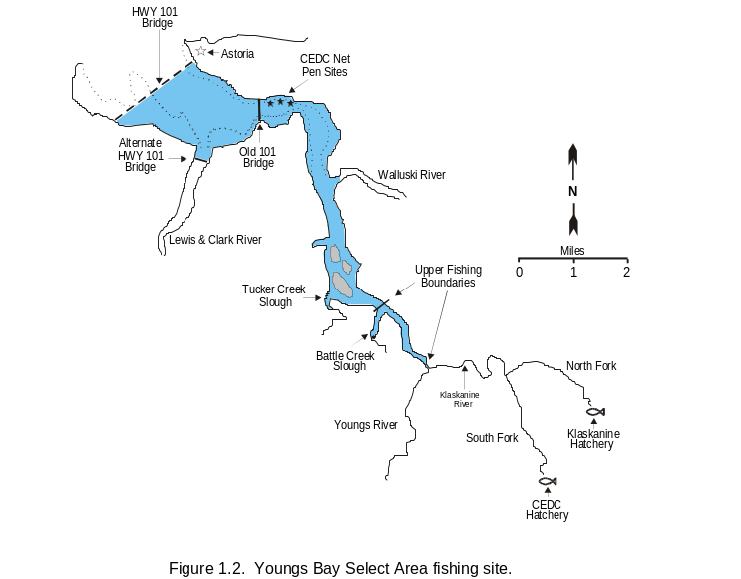Youngs Bay is located in Oregon waters adjacent to the city of Astoria and inland of the Highway 101 Bridge (Figure 1.2). The upper fishing boundary is the confluence of Youngs and Klaskanine rivers for all fisheries except for the fall commercial fishery when the boundary is moved downstream to Battle Creek Slough to increase SAB fall chinook (O. tshawytscha) broodstock escapement. All waters in this site are under Oregon State jurisdiction with an Oregon landing permit required for participation. Youngs Bay presently has 76 net-pen structures.

Tongue Point / South Channel
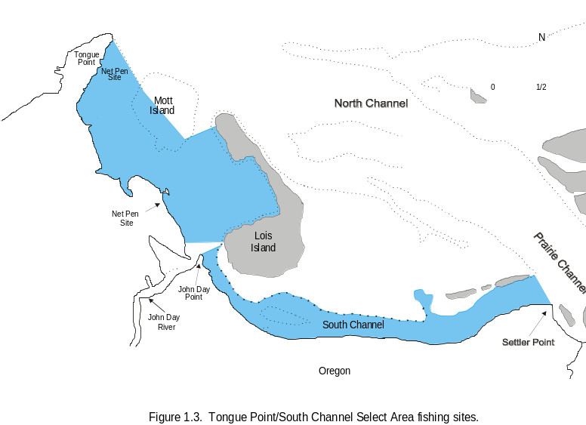
Tongue Point Basin is located just east of Astoria, Oregon in the concurrent Columbia River waters bounded by the Oregon shore and Mott and Lois islands (Figure 1.3). The fishing area includes waters of South Channel. All waters in this site are under concurrent state jurisdiction. There are 37 net-pen structures in the Tongue Point basin.

Blind Slough/Knappa Slough

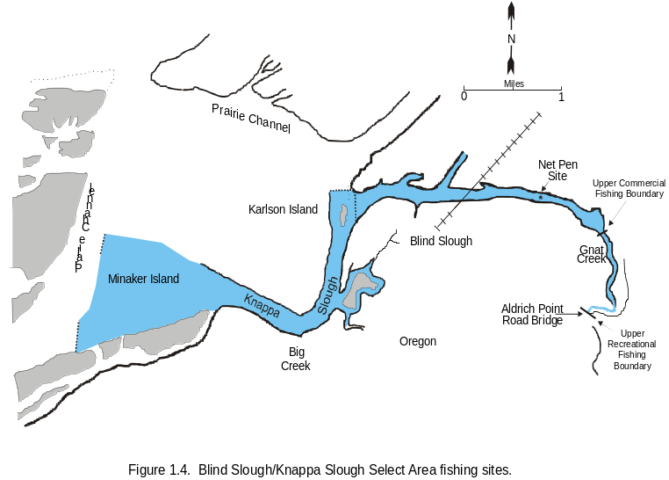Blind Slough is located near Brownsmead, Oregon and includes waters of Gnat Creek and Knappa Slough (Figure 1.4). The Blind Slough fishing area is approximately 2.5 miles long. Concurrent waters extend downstream of the railroad bridge. Oregon State waters extend upstream of the railroad bridge in Blind Slough. Seventeen net pens are located in Blind Slough.

Deep River
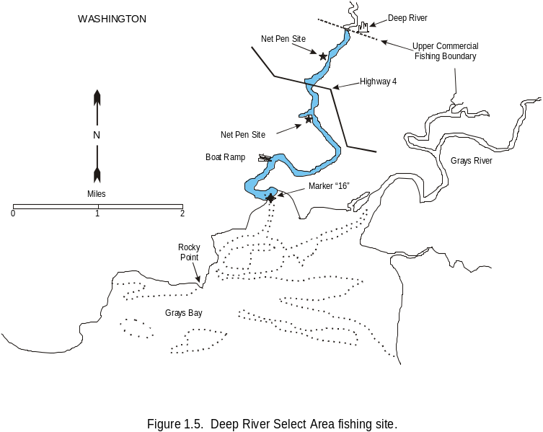
The Deep River fishing site is located within the lower reaches of Deep River below the town of Deep River, Washington and extends downstream approximately 3 miles to the confluence at Grays Bay with the lower Columbia River (Figure 1.5). Washington State waters extend upstream of the Highway 4 bridge and concurrent state waters extend downstream. Deep River includes two net-pen sites with a total of 38 net pen structures.

Hatcheries

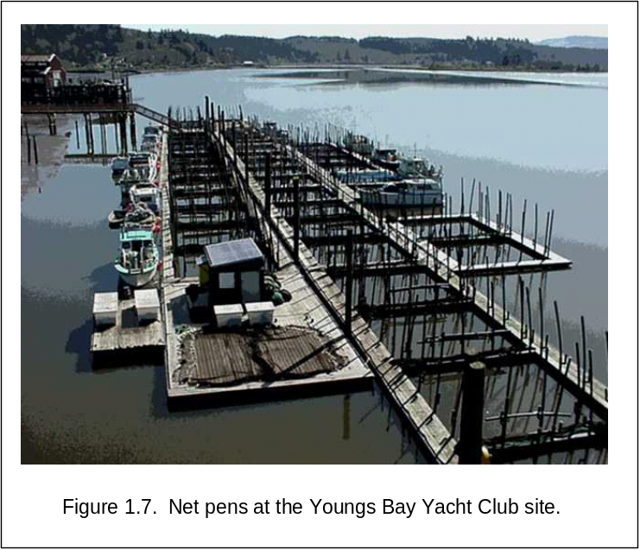
The SAFE project fully funds Gnat Creek and Grays River hatcheries and has partially funded Klaskanine Hatchery. This proposal includes expansion of funding to include 750,000 increased coho production at Klaskanine Hatchery (100% funding). Other hatcheries providing production for the net-pen sites are South Fork Klaskanine (CEDC); Big Creek, Bonneville, Cascade, Gnat Creek, Klaskanine, Oxbow, Sandy, and Willamette (all ODFW); and Cowlitz, Elochoman, Lewis, and Gray’s River (all WDFW). A summary of each facility's association with the SAFE project is provided in Table 1.1.

Most of the hatcheries funded by the project will need a degree of upgrading by 2009. The Grays River Hatchery presently has bacterial problems in one of its rearing ponds that will need lining in the next year or so. Klaskanine Hatchery will require maintenance and updates to the incubation system and raceways, including raceway spouts, dam boards and screens. Gnat Creek Hatchery will require routine maintenance.

Net-Pen Structures

Each net-pen rearing complex consists of 2-4 individual 6.1-m² inside dimension frames of high-density polyethylene pipe (33 cm o.d.) filled with styrofoam (Figure 1.7). A wooden walkway of 2” x 12” lumber is bolted to the plastic frame for access. A 3.1-m deep net hung within each frame confines the fish during rearing and acclimation. Mesh sizes of 3.2-19.0 mm (0.125-0.750”) are utilized and adjusted depending on fish size. Vertical plastic standpipes are submerged around the perimeter of each pen to maintain the shape of the net. Actual rearing area of each net is approximately 91 m³ (3,200 ft³).Fish are grown and released from these pens under varying management and grow-out regimes including two-week acclimation, over-winter, and full-term net-pen rearing.
Other Equipment
CEDC has two 8’ X 20’ barges equipped with outboard motors, a net washer, fork lift (BPA surplus) and other miscellaneous equipment necessary for operation and maintenance of the net pens. CEDC’s South Fork Hatchery has all equipment necessary for propagation (incubators, pumps, etc.) and a forklift (BPA surplus). Administrative office is adequately equipped with computers, copiers, etc. Two vehicles are leased through General Services Administration and an older truck (1984) is owned by the project.
In addition to the net pens and associated structures, WDFW possesses two Hydrolab water chemistry meters for monitoring essential chemistry at each net-pen site. Grays River Hatchery is fully funded by this proposal and has all necessary equipment for incubation, fish rearing and routine hatchery operations. The administrative office has one PC and one laptop.
The ODFW portion of the project includes full financial support of Gnat Creek Hatchery and associated equipment including a small tractor and water pumps. The proposal will provide 100% funding for Klaskanine Hatchery. Three vehicles associated with the ODFW portion of the SAFE Project are leased.

Table 1.1. Summary of salmonidª production facilities associated with the select area fisheries project, 1993-2005.
 |  | Early Rearing |  |  |  |  | Direct Release
Hatchery | Agency | COH | CHS | SAB | URB |  | COH | CHS | SAB
Oregon
Big Creek | ODFW | X |  | X |  |  | X |  | X
Bonneville | ODFW | X |  |  | X
Cascade | ODFW | X
Eagle Creek | USFWS | X
Gnat Creek | ODFW |  | X
Klaskanine River | ODFW |  |  | X |  |  |  |  | X
Oxbow | ODFW | X
Sandy River | ODFW | X
S. Fork Klaskanine | CEDC | X |  |  |  |  | X | X
Willamette | ODFW |  | X
Washington
Cowlitz River | WDFW |  | X
Lewis River | WDFW |  | X
Elochoman River ^{b} | WDFW | X
Grays River | WDFW | X | X |  |  |  | X
ª Coho (COH); spring chinook (CHS); select area bright (SAB) fall chinook (Rogue River stock); upriver bright fall chinook (URB)
^{b} Discontinued in 2004

H. References

Brannon, E., et al. 2004. The Controversy about Salmon Hatcheries. “Fisheries” Vol. 29 No 9.

Bowers, Wayne and Steven King, Oregon Department of Fish and Wildlife, Tom Clune, CEDC Fisheries Project (BPA), James Hill, CEDC Fisheries Project. 1986Commercial Salmon Fishery and Artificial Production Programs of Youngs Bay, Oregon, May 1986.

Dudiak, N., Boyle, L., and Hauser, W.J. 1985. Imprinting Salmon in Saltwater in Southcentral Alaska. Alaska Department of Fish and Game, Anchorage, Alaska

Eastern Basin Chinook Study, (author not identified). Bureau of Fisheries 1999-2000
<www.dec.state.ny.us/website/dfwmr/fish/argrlake.pdf>

Hirose, P., M. Miller, and J. Hill. 1996. Columbia River: Terminal Fisheries Research Report; 1994 annual report. Project 93-060 Annual Completion Report for the Bonneville Power Administration, Portland, Oregon. 151 pp.
Hirose, P., M. Miller, and J. Hill. 1998. Columbia River: Select Area Fishery Evaluation Project; 1995-1996 annual reports. Project 93-060 Annual Completion Report for the Bonneville Power Administration, Portland, Oregon. 194 pp.
IEAB (Independent Economic Analysis Board). 2002. Artificial production review – economic analysis Phase 1. Summary report on IEAB task 56 prepared for the Northwest Power Conservation Council, July 9, 2002. Available at: http://www.nwcouncil.org/library/ieab/ieab2002-1.htm
Lang, Dr. Bill. Columbia River, Center for Columbia River History
www.ccrh.org/river/history.htm
Ledgerwood, R. and Ryan, Brad A. 1997. Estuarine and Nearshore-Ocean Behavior of Juvenile Spring Chinook Salmon from the Columbia River, National Marine Fisheries Service, Northwest Fisheries Science Center, Fish Ecology Division.
Levings, C. D., C. D. McAllister, and B. D. Chang. 1986. Differential use of the Campbell River estuary, British Columbia, by wild and hatchery-reared juvenile chinook salmon (Oncorhynchus twshawytscha). Canadian Journal of Fisheries and Aquatic Sciences 43:1386-1397.
Lichatowich, Jim. 1999. Salmon Without Rivers.

Lower Columbia Fish Recovery Board. Draft 2004. Lower Columbia Salmon and Steelhead Recovery and Subbasin Plan, Technical Foundation Vol III Other Species. Lower Columbia Fish Recovery Board, Longview, Washington.
Martin, Irene. 2005. A Social Snapshot of the Columbia River Gillnet Fishery, Unpublished. Prepared for Salmon for All. Astoria, Oregon
Miller, M., J. North, P. Frazier, T. Jones, A. Dietrichs, and T. Miethe. 2002. Select Area Fishery Evaluation Project. 1997-2000 Annual Completion Report for Project #199206000 prepared for the Bonneville Power Administration, Portland, Oregon. 94 pp.
Myers, K. W., and H. F. Horton. 1982. Temporal use of an estuary by hatchery and wild juvenile salmon. Pages 377-392 in V. S. Kennedy (editor), Estuarine Comparisons. Academic Press. New York, NY.
NMFS (National Marine Fisheries Service). 1998. Endangered Species Act – Section 7 consultation biological opinion. Impacts of select area fisheries enhancement project (SAFE) on salmon and steelhead species in the Columbia River Basin listed under the Endangered Species Act. NMFS, Northwest Region, Seattle, WA, 15 pp.
NMFS (National Marine Fisheries Service). 2003a. Endangered Species Act (ESA) Section 7 consultation – Supplemental Biological Opinion. Supplemental Biological Opinion to the 2001 U.S. v. Oregon “Interim management agreement for upriver spring chinook, summer chinook, and sockeye on salmon and steelhead listed under the Endangered Species Act”, covering winter, spring, summer season treaty and ono-indian Columbia River Basin fisheries for 2003-2005. Consultation Number F/NWR/2003/00357. Issued July 11, 2003. NMFS, Northwest Region, Seattle, WA. 21 pp.
NMFS (National Marine Fisheries Service). 2003b. Biological Opinion on impacts of treaty indian and non-indian fall season fisheries in the Columbia River Basin in year 2003, on salmon and steelhead listed under the Endangered Species Act. Consultation Number F/NWR/2003/00865. Issued July 30, 2003. NMFS, Northwest Region, Seattle, WA. 70 pp.

North, J., C. Rodriguez, M. Miller, J. Sewall, P. Frazier, S. Gray, T. Jones, A. Dietrichs, T. Miethe. 2004. Select Area Fishery Evaluation Project, Final Completion Report for Project #199206000 prepared for the Bonneville Power Administration, Portland, Oregon. 143 pp.

ODFW and WDFW. 2000. Status Report: Columbia River fish runs and fisheries, 1938-1999. Joint staff report of the Oregon Department of Fish & Wildlife (ODFW) and the Washington Department of Fish & Wildlife (WDFW), Clackamas, OR; Vancouver, WA.

Oregon Department of Fish and Wildlife. 2003. Fish Hatchery Management Policy. May 2003

Oregon Department of Fish and Wildlife. 2003. Native Fish Conservation Policy. September 2003.

Regional Plan, Lower Columbia River Salmon Recovery and Fish and Wildlife Subbasin Plan. December 15, 2004.

Salmon For All. 1996. Lower Columbia River Salmon Business Plan for Terminal Fisheries, Final Report. Prepared for US Department of Energy, Bonneville Power Administration Environment, Fish and Wildlife, July 1996.
Warren, Robert. 2005. Emigration rate of net pen reared spring Chinook salmon from Youngs Bay, Oregon and an investigation of the relationship of gill Atpase on migratory behaviorColumbia River Estuary Study Taskforce, Unpublished. Prepared for Salmon for All, Astoria, Oregon.

Williams, J., G. Matthews, J. Meyers, S. G. Smith, T. Cooney, and C. Toole. 1988. Hatchery extra mortality hypothesis. WOE Appendix Submission 1. June 30, 1998.
I. Key personnel

Geoffrey S. Whisler

Oregon Department of Fish and Wildlife
Ocean Salmon & Columbia River Program
17330 SE Evelyn Street
Clackamas, Oregon 97015
Office: (503) 657-2000 x246

Email: geoffrey.s.whisler@state.or.us

Current Position: Select Area & Estuary Fisheries Project Lead
Current Duties (0.75 FTE):
Fisheries Management
- Prepare Biological Assessments for Select Area (SAFE) fisheries as required by NOAA Fisheries.
- Prepare Select Area sections of annual Columbia River Management Joint State (OR and WA) Reports for public review.
- Conducts annual spring and fall public meetings and surveys to develop Select Area fishery seasons.
- Develop Select Area fishery proposals including area, gear, and time restrictions. Present seasons via Compact/Joint State Hearings, Fact Sheets, and Compact Actions notices. Develop sport fishing regulations and assist with development of ODFW angling synopsis.
- Assist with preparation of Oregon Administrative rules related to Select Area commercial and recreational fisheries.
- Coordinate fisheries enforcement with Oregon State Police.
- Monitor landings and fishery sampling data in season. Modify season structure as needed to maximize harvest and minimize impacts to listed salmonids.
- Serve as ODFW’s technical expert on Select Area fisheries and participate in Compact process.

Select Area Fisheries Project Evaluation
- Analyze coded-wire tag recovery data obtained from Regional Mark Information System for run reconstruction. Evaluate smolt-to-adult survival rates, straying, stock and age composition, and contribution (numbers and economic value) of Select Area production to regional fisheries.
- Determine optimum release strategies to maximize economic value of SAFE production and minimize impacts to wild stocks.
- Determine need for, and assist with design of special projects to evaluate SAFE Project activities including telemetry, net-pen towing, and treatment-control release-strategy evaluations.
- Coordinate test fishing activities for broodstock collection, harvest management, and evaluation of sites and/or release strategies. Prepare invitations to bid and contracts for work as needed.
- Assist with preparation of annual reports summarizing activities and results of the Select Area Project.

Administrative
- Supervise work of ODFW commercial fishery staff (SAFE and mainstem) including scheduling of fishery sampling, stream surveys, test fishing, and hatchery assistance.
- Develop and submit work statements and budgets for ODFW components of the SAFE Project (Management, Gnat Creek Hatchery, and Klaskanine Hatchery).
- Track ODFW SAFE Project expenditures and budgets.
- Submit SOWs and budgets in PISCES and submit progress reports.
- Coordinate with ODFW Propagation staff to plan production, mass-marking, and coded-wire tagging needs for SAFE Project.
- Develop and submit Biological Assessments addressing effects of production and other projects as needed.
- Coordinate activities with CEDC Fisheries Project staff and WDFW staff as needed.
- Answers questions from fishers and general public on salmonid life histories, Select Area fishery regulations, etc.

Education: Bachelor of Arts conferred by Linfield College McMinnville, OR in 1995. Major course of study: Biology, minor in chemistry.

Summary of qualifications
- 10+ years experience planning, conducting, and coordinating fish surveys and studies
  - 5 years leading research studies
  - 10 years experience with Columbia River commercial and recreational fisheries

Work Experience:
Project Leader (SFWB) ODFW - Select Area & Estuary Fisheries Project Leader 4/06 – present
Design, coordinate, implement, and manage Select Area fisheries in the lower Columbia River, oversee sampling of mainstem commercial fisheries, supervise Astoria field office.
Research Crew Lead USGS – Catostomid population studies 2/04 – 2/06
Assist with long-term monitoring program for Endangered Species Act (ESA) listed catostomid populations in Upper Klamath Lake and Klamath Basin.
Asst. Project Leader ODFW – Live Capture Commercial Fisheries 3/01 – 2/04
Lead Oregon Department of Fish and Wildlife (ODFW) researcher on multi-faceted projects investigating methods to increase species and stock selectivity in Columbia River commercial salmon fisheries. Focus on means to successfully live capture and release federally-listed stocks while providing harvest opportunity on hatchery-origin stocks.
North Coast Crew Lead ODFW – Coastal Salmonid Inventory Program Winter 98-00
Supervise field activities of seasonal staff conducting spawner surveys of federally-listed and non-listed salmonid stocks; Facilitate conduction of surveys; Participate in project administration and pre-season training
Crew Lead ODFW - Sturgeon Capture/Recapture Project & Commercial Fisheries 4/98 – 10/98
Assist in planning and conducting sturgeon capture/recapture project in the Columbia River and coastal estuaries; Crew lead plus train and supervise other crew leaders sampling Columbia River mainstem and SAFE commercial gillnet fisheries; Assist in planning commercial fishery monitoring
Crew Lead ODFW - Columbia River Fisheries 3/97-2/98, 99-00
Crew lead lower Columbia River and coastal estuary sturgeon capture/recapture project; co-author of report; Crew led salmonid juvenile and spawner surveys; Lead author and co-author of reports; On-board monitoring of commercial gillnet fisheries (Columbia River mainstem and SAFE); Analysis of salmonid scales: identification of age, species, and stock; Collect and prepare juvenile salmonid tissue samples for electrophoresis; Develop catch estimates for recreational sturgeon fishery

Selected Publications:
Whisler, G.S., and J.A. North. 2004. Review of the bycatch estimator used in the 2002-2003 non-treaty spring chinook selective and live capture commercial fisheries. Oregon Department of Fish and Wildlife whitepaper. 13p.

Whisler, Geoffrey S. 2003. Evaluate live capture selective harvest methods for commercial salmon fisheries on the Columbia River. Final Report on 2001 Field Season. Oregon Department of Fish and Wildlife Report to Bonneville Power Administration. Contract 2001-007-00. 33p.

North, J.A., and G.S. Whisler. 2002. Information relative to gear modifications for 2003 mainstem spring chinook live-capture fisheries. Informational whitepaper prepared for Columbia River Compact and Columbia River fishery managers. 10p.

Whisler, G.S., and S.E. Jacobs. 2001. Prediction of 2001 Ocean Abundance of Rogue River Fall Chinook Salmon. Oregon Department of Fish and Wildlife Annual Report.

Whisler, J., T. Neill, K. Melcher. 1999. 1998 Sturgeon Tagging Project in Select Coastal Estuaries. Oregon Department of Fish and Wildlife Report.

Marc Miller
Fishery Biologist

Project Leader, Washington Department of Fish and Wildlife
millemcm@dfw.wa.gov

Duties: 1 FTE
Duties divided fairly evenly between management and rearing of SAFE project salmon.
Management responsibilities include finding net pen sites, establishing contracts with local landowners, establishing standards for rearing and monitoring net pen fish, conducting fishery monitoring program, reporting in-season on fishery harvest, developing and conducting stream survey research, reporting on all results of SAFE project.
Rearing responsibilities include locate, design and construct each net pen site, define rearing plans for each site, identify areas of concern or opportunity and initiate all changes.
Position includes all tasks related to project design, budgeting, permitting, and project proposals.

Education: Graduated from Franklin High School (Seattle) in 1964, and from Humboldt State University in 1973 with Bachelor of Science in Fishery Biology.

Work Experience:
Employed as Fishery Biologist with Washington Department of Fish and Wildlife from 1977 to present as follows:
- 1993-present, Project leader of Columbia River select area fishery evaluation (SAFE) project, supervising creation, researching and reporting progress of net pen rearing in Washington sites.
- 1990-93, Project leader of genetic stock identification sampling program, creating baseline of genetic samples from major Pacific coast river systems for chinook, coho, and chum salmon. Sampled many fisheries for estimates of stock composition of catch.
- 1979-90, Project leader of ocean salmon fishery monitoring program, supervising, biological sampling and reporting on all commercial troll and recreational salmon landings between Ilwaco and Neah Bay, WA.
- 1977-79 Biological assistant in writing of first PFMC ocean salmon management plan.
- 1967-70 and 1974-76, Morocco and El Salvador in 1967-70 and 1974-76 researching offshore bottom fish populations with US Peace Corps.

Recent accomplishments:
Design all phases of Washington SAFE project, including establishment of each site, setting of fishery regulations, and design of water quality monitoring program.
Bringing Grays River Hatchery on-board after being cut due to reduced Mitchell Act funding.
Initiated spring chinook rearing in Deep River for increased commercial and recreational harvest of spring chinook. Made several changes to spring chinook rearing practices to improve survival and increase production.

A major contributor to the following documents in present position:
Hirose, P., M. Miller, and J. Hill. 1996. Columbia River: Terminal Fisheries Research Report; 1994 annual report. Project 93-060 Annual Completion Report for the Bonneville Power Administration, Portland, Oregon. 151 pp.
Hirose, P., M. Miller, and J. Hill. 1998. Columbia River: Select Area Fishery Evaluation Project; 1995-1996 annual reports. Project 93-060 Annual Completion Report for the Bonneville Power Administration, Portland, Oregon. 194 pp.
Miller, M., J. North, P. Frazier, T. Jones, A. Dietrichs, and T. Miethe. 2002. Select Area Fishery Evaluation Project. 1997-2000 Annual Completion Report for Project #199206000 prepared for the Bonneville Power Administration, Portland, Oregon. 94 pp.
North, J., C. Rodriguez, M. Miller, J. Sewall, P. Frazier, S. Gray, T. Jones, A. Dietrichs, T. Miethe. 2004. Select Area Fishery Evaluation Project, Final Completion Report for Project #199206000 prepared for the Bonneville Power Administration, Portland, Oregon. 143 pp.

Tod A. Jones
Project Manager, Clatsop Economic Development Council Fisheries Project (CEDC), Clatsop County Government
tjones@co.clatsop.or.us

Duties: 0.75 FTE
Plan, organize and manage operations for the CEDC Fisheries contingent of the SAFE project. Oversee the development of statements of work and budgets, develop fish rearing strategies toward fisheries development to meet project goals, help with coordination of work elements to meet milestone time frames, maintain dialogue with fishermen and processors for the voluntary poundage assessment participation and make hiring and termination decision recommendations.

Education: Peninsula Jr. College, Port Angeles, Washington 1963/1965. Bachelor of Science Degree, Central Washington University 1967, Ellensburg, Washington
Graduate Studies: University of Alaska, Juneau, Alaska; Cold Water, Aquaculture and Resource Management

Work Experience:
- July 2001- Present; Project Manager, CEDC Fisheries Project, Clatsop County, Oregon. Plan, organize and manage operations of the CEDC Fisheries Project in accordance with the economic development objectives and goals of the Clatsop Economic Development Council as approved by the Board of Commissioners. Secure funding and coordinate fish production programs funded by state and federal agencies for a program that produces 4 million salmon annually for commercial and recreational fisheries. Participate in public outreach programs with educational institutions such as the Astoria and Warrenton High School aquaculture programs.
- June 1997- 2001 General Manager: Bahá’í World Centre, Haifa, Israel; Supervised seven departments with total budget of $30 million.
- December 1977 - January 1997 General Manager and CEO, Alaska Aquaculture, Inc.
- June 1975 -1977 Sales Representative, Alaska Hydrotrain; one of two major ocean carriers transporting freight into Alaska.
- June 1970 -1975 Operations Manager, Sea Land Services, Inc.; an international container-shipping company serving Alaska.
- September 1967-1970 High School Biology and Science teacher, Eureka High School, Eureka, Montana.

Accomplishments:
- Scholastic Achievements: Honors Program, Deans List, Interdisciplinary Award, Central Washington University
- Invented and developed the Salmon Egg Planting Device and Method, a patented process of planting salmon eggs in stream beds resulting in high egg-to-fry survival.
- Designed, built and managed a 111 million egg salmon hatchery with specially designed deep matrix incubation system. Owner/operator two seine boats for terminal harvest operations.
- Designed and built salmon processing facility for hatchery cost recovery harvest. Managed the central incubation facility incubating 111 million eggs, two net pen grow-out sites.
- Designed and built floating raceways for grow-out of chinook and coho smolts.
- Drafted the first Environmental Impact Statement for salmon hatchery in Tongass National Forest.
RESPONSE TO INDEPENDENT SCIENTIFIC REVIEW PANEL

199306000 - Select Area Fisheries Enhancement Project
Sponsor: Oregon Department of Fish & Wildlife (ODFW)
Province: Columbia Estuary Subbasin: Columbia Estuary
Budgets: FY07: $1,804,868 FY08: $1,779,000 FY09: $1,827,028
Short description: This project produces known stock anadromous salmonids for commercial and recreational harvest in Select Area and other regional fisheries.
Recommendation: Response requested

This is essentially an ocean ranching plan, where hatchery fish are stocked directly into coastal areas of the Columbia estuary and harvested there on return. The technique is a unique and relevant mitigation for lost Columbia fisheries due to dams. Catch rates and benefit:cost ratios appear among the highest of artificial production projects in the basin. The proposal reviewed provided evidence of success, was well prepared, and indicated that the sponsors were receptive to previous ISRP reviews and suggestions, and responded quite well to these. Furthermore, there were positive examples of adaptive management, where some releases were discontinued based on straying rates evident from coded-wire tag (CWT) information.

While there was evidence of monitoring and adaptive management, improved monitoring and evaluation is suggested. The underlying assumption of this project is that one can continually release hatchery smolts directly into the ocean without limitation, or at least without density-dependent impact on wild stocks. This remains to be tested. No plan is presented here, and it would be difficult to develop a testable design. Nevertheless, the question on ocean limitations remains, and an attempt should be made to develop the experiment(s).

Project sponsors are aware of concerns about hatchery smolt releases and potential effects to wild stocks. Columbia River hatcheries release approximately 135 million smolts annually. The SAFE program currently releases less than 5 million smolts each year representing less than 3.7 percent of the basin’s hatchery production.

Research into the outmigration timing of SAFE smolt releases has been conducted and is planned to continue in the future. Ledgerwood (1997) found acoustic-tagged spring chinook smolts released from Youngs Bay net pens emigrated from Youngs Bay within one full tidal series and moved through the Columbia River estuary rapidly. An ODFW R&E-funded telemetry study conducted in 2003-05 (see pages 110-111 of North et al. 2006) also documented rapid rate of spring chinook outmigration and, by extension, limited potential for interactions with naturally produced smolts in the estuary. Average travel time was 11.5 and 48.7 hours from Youngs Bay net pens to the mouth of the Columbia River in 2004 and 2005, respectively (personal communication; Robert Warren; Sea Resources and Columbia River Estuary Study Taskforce (CREST)). As funding sources are identified these studies will be continued to quantify parameters of interest for all sites and species released.

The question of ocean limitations and interactions between hatchery and naturally produced salmonids in this environment is complex and will take the coordination of several entities and specialists to simply construct a framework to develop an answer. Juxtaposing current salmonid production levels with estimates of historical production is somewhat informative. Historically, an estimated 10-16 million adult salmonids returned to the Columbia River to spawn annually; currently 1-3 million salmonids return, the product of natural spawning and hatchery releases. It may be reasonable to assume that smolt production would currently be an order of magnitude less than it was historically. Of course the fact that Columbia River production was historically higher does not rule out the potential for density-dependent limitations. Ocean productivity may be much different now than historically. This exercise also does not take into account inherent differences between hatchery and wild fish. We concur that the question of hatchery releases affecting wild smolts in the ocean environment is of importance. We also agree with the ISRP recommendation to Council that methods be developed to evaluate the effects of large-scale artificial production programs for harvest on naturally produced salmon populations. However, we believe this question cannot be adequately addressed within the scope of the current SAFE project but we would be willing to partner with others in the basin to attempt to answer these questions.

M&E might be further improved with better catch records and less reliance on coded-wire tags. Other, perhaps more reliable forms of catch reporting should be explored.

Harvest estimates of all commercial catch in Washington and Oregon are calculated from fish tickets completed at the time of sale. Every landing must be recorded at this time on a fish ticket that includes a unique ticket number, gear type, the catch area, and the number and pounds landed by species. Copies are phoned in daily to that agency’s in-season managers and sent regularly to the management agency’s central office. At the time of sale landings are sampled for average weight as well as fin marks and CWTs with associated biological information. Coded-wire tag (CWT) data is used primarily to determine survival rates and stock composition of the landed catch rather than to estimate numbers of harvested fish. It is important to note that biological sampling rates associated with SAFE fisheries are generally higher than mainstem Columbia fisheries.
Fishery managers produce catch estimates from fish ticket and sampling data to monitor progress of the fishery and the management agency provides post-seasonal summaries of catches by area. There is a very high degree of confidence in the accuracy of harvests reported from small fisheries such as the SAFE fisheries since on-site monitoring can account for the vast majority of the landings. This is compared regularly with in-season and post-season fish ticket data to confirm its completeness.

To provide more detailed information, the following is excerpted from pages 38-39 of North et al. (2006) and describes methods used in commercial and recreational fishery catch accounting including estimators of stock composition and total harvested numbers.

DATA COLLECTION

Select area commercial and recreational fisheries are monitored extensively throughout the year to ensure adequate representation of the catch and to determine impacts to non-local stocks based on in-season updates of mainstem salmon and steelhead returns. The ODFW and the WDFW are responsible for sampling their respective SAFE fisheries to collect biological data and for summarizing data to estimate landed catch. The landed catch from all SAFE fisheries is sampled for biological information, including scale samples and the recovery of CWTs. Each SAFE site is monitored separately to account for variability in total landings, and species, stock, and age composition within each fishery. Funding for fishery sampling is provided by the BPA through the SAFE project (BPA #1993-06000) in Oregon and Washington, and also by the coded-wire tag recovery project (BPA Project #1982-01301) in Oregon.

Commercial Fisheries

Sampling of SAFE commercial fisheries includes collecting representative weight and length data by species, examining the catch for any external tags or marks and collecting visual stock identification (VSI; spring chinook only) information. Scales and CWTs are collected for age and stock composition analyses and to determine straying and survival rates. All snouts are delivered to tag recovery labs in Clackamas, Oregon or Olympia, Washington where the CWT is extracted and decoded. The resulting tag code is entered and verified on a mainframe computer. The CWT recovery data are summarized to estimate the number of CWTs recovered for each tag code for each sampling program. Associated fishery/recovery and biological data collected when snouts are recovered, are entered into electronic databases, uploaded to the mainframe computer, and merged with corresponding CWT recovery data. Data is then transferred to the Pacific States Marine Fisheries Council (PSMFC), where individual tag recoveries are expanded based on program-specific weekly and site-specific sampling rates to estimate the total number of a particular tag code present in a given fishery. The data is then posted on the Regional Mark Information System (RMIS) website for use by fishery managers in making fishery management decisions and conducting run reconstructions. Preliminary data are summarized immediately after each fishing period and used for in-season management.

Minimum target sampling rates are 20 percent of the landed catch by area and season; however, sampling rates are usually significantly higher. During 2001-2005, over 118,000 (28 percent) of all salmon harvested in SAFE fisheries were examined for fin marks with season-specific sampling rates of 52, 47, 43, and 26 percent in winter, spring, summer, and fall seasons, respectively (Table 3.1). As a rule, more intensive sampling is conducted whenever a new site or season is established. For instance, the sampling rate for 2003-2005 spring seasons in Deep River was 100 percent of the landed catch, since fish could not lawfully be removed from the area prior to inspection by WDFW staff. Similar rules were in effect for other SAFE sites when fisheries were first implemented. Preliminary landings are summarized by statistical week based on phone surveys of buyers and processors. These landings are later confirmed with actual point-of-sale fish tickets. Average fish weight data from the sampled catch collected at buying stations is applied to species-specific landings (in pounds) by week to determine the number of fish landed by species for each select area. Coded-wire tag and VSI (spring chinook) data is summarized to determine stock compositions of fish landed in each SAFE fishery. Stock compositions are then applied to total landing estimates to produce stock-specific catch estimates. Stock-specific catch estimates for fisheries are monitored in conjunction with in-season run size updates to maintain fisheries within ESA guidelines. (Emphasis added)

Recreational Fisheries

Prior to 2002, a modified and limited creel census program was used to estimate sport catch in select areas. Since then, a more extensive program has been implemented in response to increased sport fishing effort. Recreational angler surveys are currently conducted in Youngs Bay, Knappa Slough, Blind Slough, Big Creek, and Gnat Creek during the spring and in the Klaskanine River and tidewater sections of Youngs River during the fall. Depending on the specific site and fishery, fishing effort is estimated by counting one of the following: 1) trailers at the primary launch sites, 2) vehicles parked at access points, 3) boats from observation points, or 4) anglers exiting the fishery. In some fisheries with boat and bank access, several methods are used to accurately reflect effort. Aerial flight data obtained from mainstem Columbia River surveys are used to corroborate effort counts or to supplement counts on days when ground surveys are not conducted. Effort data is stratified by day-type (weekday or weekend/holiday) and month and expanded for non-survey days to estimate total effort for each fishing site. Catch rates are determined primarily from angler interviews and verified in some cases with voluntary harvest log books. Catch-per-angler-day is estimated by expanding survey data for non-surveyed hours. Total catch by species is estimated by applying expanded catch rate data to estimates of effort by fishing area.

The landed catch is sampled to collect biological information, recover CWTs, and determine stock composition. Scales are collected to determine age structure of the landed catch. Coded-wire tag (or VSI) data are applied to the estimated landings for each site to estimate impacts to listed species. (emphasis added)

Management of salmon fisheries on the west coast of North America is dependent on the CWT program. The SAFE project monitoring adheres to the protocol set by the CWT program design. Project sponsors and agencies have reviewed and are aware of limitations and concerns surrounding the CWT program as reported by the Pacific Salmon Commission’s Expert Panel in PSC (2005). The panel reported several concerns and strategies to refine the program in light of new management approaches such as mass marking and mark selective fisheries. They also asserted the importance of the program:

The coded-wire-tag (CWT) system has provided a practical and efficient means for stock and fishery specific assessment for Pacific salmon because it: (a) includes fully integrated tagging, sampling, and recovery operations along the entire west coast of North America; (b) has sufficient resolution for specific assessments of uniquely identifiable experiments; (c) provides data conducive to standardized methods of analysis of stock and fishery assessments; and (d) facilitates multi-decade evaluation of trends in stock and fishery statistics such as survival indices and brood exploitation rates.
……………..
The CWT system is the only technology that is currently capable of providing the data required by the PSC’s Chinook and Coho Technical committees. There is no obvious viable short-term alternative to the CWT system that could provide the data required for cohort analysis and implementation of PST management regimes for chinook and coho salmon. Therefore, agencies must continue to rely upon CWTs for several years (at least 5+ years), even if agencies make decisions for development and future implementation of alternative technologies.

Research on straying or habitat use could be possible by collaboration with other tagging studies.

Data on straying and habitat use is collected during the sampling of hatchery returns region-wide and during surveys of spawning in natural habitats (includes SAFE-specific surveys and other programs in Oregon and Washington). The Oregon Department of Fish and Wildlife’s Coastal Salmonid Inventory Project conducts annual surveys of salmon spawning habitat in lower Columbia tributaries to develop population abundance estimates. Standard data collection includes CWT and fin mark recovery data which is communicated to SAFE staff. CWT recoveries regardless of the collection source can be accessed via the Regional Mark Processing Center (RMPC, formerly RMIS) and are used to calculate contributions to other fisheries and homing tendency.

SAFE produced fish can be identified by CWT recovery and in the case of SABs a unique identifying fin mark (left-ventral fin clip). As referred to in the introductory comment by ISRP this unique fin mark provided data on stray rates of SABs released at Big Creek Hatchery and led to a change in release location. Consistent with hatchery production protocol in the Columbia Basin, spring chinook and coho are mass-marked with an adipose fin clip. Potential improvements to the current monitoring system would necessitate increased proportions of CWT groups within release groups, additional adult surveys for tag recovery, and/or other methods of uniquely identifying SAFE produced fish (e.g. PIT tags, otolith marking, or fin marks). Any changes to current study design would require tests of power to balance statistical significance with costs and need the ability to be integrated with the current dataset. The exploration of potential modifications would benefit from the establishment of a statistical support facility as recommended to Council by ISRP.

As mentioned above, smolt outmigration telemetry studies have been conducted and are planned to continue. This study quantified migration timing and provided insight on potential for interaction in the estuary and some data on habitat usage.

Fishing effort is designed to focus on areas of hatchery fish release. Nonetheless, a review of possible mixed-stock fisheries impacts may also be required, where some of the capture fisheries intercept other stocks.

A small number of non-local fish are encountered in SAFE fisheries, both ESA-listed and non-listed stocks. Impacts to listed stocks resulting from Select Area fisheries are covered under two separate Biological Opinions (BOs) issued for mainstem Columbia River spring and fall fisheries (NMFS 2003a; NMFS 2003b). Hatchery production by the SAFE Project is currently covered in a separate BO issued in 1998 (NMFS 1998). The current production BO is scheduled to be renewed concurrent with the ongoing Hatchery Genetic Management Plan (HGMP) process (Richard Turner-NOAA, personal communication). Existing and previous BOs have found the project does not likely jeopardize the continued existence of listed salmonid stocks in the Columbia River Basin.

One of the primary goals of this project was to maximize harvest of returning adults while minimizing catch of non-SAFE stocks. Coded-wire tag recoveries document extremely high harvest rates for all species: coho (98.3 percent), spring chinook (92.0 percent), select area bright fall chinook (96.4 percent), and upriver bright fall chinook (94.4 percent). As intended, the majority of the fish harvested in SAFE fisheries were of local origin although the contribution varied by site and year. For 1993-2003 winter-summer fisheries, SAFE releases comprised an average of 88.9 percent of the Blind Slough harvest (1998-2003), 80.1 percent of the Youngs Bay harvest (1993-2003), 74.6 percent of the Tongue Point harvest (1998-2003), and 69.2 percent of the Deep River harvest (2003). During 1996-2002, locally-produced coho contributed an average of 87.1 percent of the coho harvest in Youngs Bay, 85.9 percent in Deep River, 81.8 percent in Tongue Point, and 81.6 percent in Blind Slough. In Steamboat Slough, SAFE coho comprised an average of 57.8 percent of the landings during 2000-2002. Fall chinook harvest and stock composition varied considerably depending on the extent of releases at each site. During 1996-2002 Youngs Bay had an average annual harvest of over 1,934 fall chinook, with 97.0 percent originating from SAFE sites based on non-expanded CWT recoveries. Tongue Point and Blind Slough averaged 438 and 581 chinook, respectively, with SAFE stocks comprising 57.6 percent of the Tongue Point catch and 58.1 percent of the Blind Slough landings. In Deep River, 67.1 percent of the average annual harvest of 106 chinook were of SAFE origin.

Allowable impacts to listed stocks are not targets but are used as guidelines in the management of the fishery. SAFE fisheries have an upriver spring chinook impact guideline of 0.1 percent and have consistently come in under this guideline. From 1993-2005 combined harvest rates on upriver spring chinook in all winter-summer SAFE fisheries have averaged 0.06 percent with a range of 0.00-0.19 percent. For all fall SAFE fisheries combined during 1993-2000, the impact rate to Snake River wild fall chinook ranged from 0.0-0.15 percent, and averaged 0.04 percent. Very few chum salmon are landed in select area fall fisheries, with impact rates not exceeding 0.24 percent in any year during the 1996-2002 seasons. Impact rates on steelhead are assumed to be low due to mesh size restrictions that generally allow most steelhead to pass through nets; results of extensive test fishing conducted during the fishery development phase of the project exhibited very low steelhead handle rates.

Due to the high harvest rate on locally-produced stocks and adaptive management techniques, SAFE fisheries have demonstrated the power of this selective fishery approach. During 2000-2004 Select Area fisheries were able to harvest 3-8 times as many spring chinook per upriver impact than occurred in mainstem Columbia River commercial fisheries.

A larger research issue requires investigation, in relation to ecosystem impact (perhaps involving EcoPath with EcoSim), locally and high seas. We suggest the sponsors partner with researchers to explore the impact to the coastal ecosystem and critical areas of the continental shelf where ecosystem changes may result from massive releases of hatchery fish.

Reviewers bring up the issue of density-dependent interactions and carrying capacity of the ocean. This debate has been around for several years (see review by Lichatowich, 1993) and is consistent with an ecosystem-based monitoring and evaluation concept. The status of pelagic communities (included salmon outmigrants) in the upwelling zone of the eastern Pacific is an important piece to this approach. The SAFE project is willing to participate in a region-wide approach to answering these questions. The EcoPath with EcoSim (EwE) modeling approach appears to be an effective, albeit complex, process involving the expertise of many fields. If successfully adapted to the upwelling zone, the use of EwE modeling would provide a clearer understanding to managers and researchers.

Growth rates and size at return (indicators of density-dependent limitations) are monitored for SAFE fish. Survival, which is not necessarily density-dependent, is also monitored extensively. These data could be used within a region-wide monitoring plan to evaluate indicators of density-dependent limitations on wild and hatchery stocks in the basin.

Non-focal species impacts from this work may be substantial in certain areas. Impact assessment should be thoroughly conducted.

Assessment of impacts to non-local salmon stocks is covered above. Handle of steelhead and cutthroat trout are minimal due to mesh size restrictions (minimum mesh sizes are mandated to reduce handle) and time and area restrictions (and low/no effort in October-mid-February). Extensive on-board fishery monitoring was conducted during the evaluation stage of the project in the mid- to late 1990s for the purpose of documenting encounter rates; observed rates were low. White sturgeon harvest is managed under a Joint State Agreement which is renewed every three years. Harvest in SAFE areas falls under the mainstem commercial guideline to maintain optimal sustainable yield (OSY). SAFE landings are managed by a cap on annual landings (400 white sturgeon total) and represent 5 percent of overall harvest. Effective regulations are in place to minimize handle and catch of both sturgeon species. Annual landings of green sturgeon in SAFE commercial fisheries have been minimal, the 1993-2005 median is one (range 0-19). In reaction to the upcoming listing of the Southern distinct population segment of green sturgeon the Columbia River Compact notified fishers that beginning July 7, 2006 green sturgeon caught in SAFE commercial fisheries must be released.

In order to monitor the impact of the fish rearing activities on the benthic macro invertebrate populations at the impact station under the net pens and at the perimeter stations at the boundaries of the mixing zones, sediment samples are collected from these areas and from reference stations well outside of the area influenced by the fish rearing activities. Animals (macroinvertebrates) are picked from these samples, preserved, identified and counted. Characteristics of the benthic populations at the impact stations and the perimeter stations are compared with those at the reference stations to look for differences that could be attributed to the fish rearing activities. The overall impact has been a minor change in macroinvertebrate populations during the rearing period (November-April) with returns to baseline levels by the beginning of the next rearing season.

Citations

Ledgerwood, R. and B.A. Ryan. 1997. Estuarine and Nearshore-Ocean Behavior of Juvenile Spring Chinook Salmon from the Columbia River, National Marine Fisheries Service, Northwest Fisheries Science Center, Fish Ecology Division.
Lichatowich, Jim; S.P. Cramer & Associates, Inc., U.S. Department of Energy, Bonneville Power Administration, Division of Fish and Wildlife, Project No. 93-013, Contract No. DE-AM79-93BP99654, 32 electronic pages (BPA Report DOE/BP-99654-6)
NMFS (National Marine Fisheries Service). 1998. Endangered Species Act – Section 7 consultation biological opinion. Impacts of select area fisheries enhancement project (SAFE) on salmon and steelhead species in the Columbia River Basin listed under the Endangered Species Act. NMFS, Northwest Region, Seattle, WA, 15 pp.
NMFS. 2003a. Endangered Species Act (ESA) Section 7 consultation – Supplemental Biological Opinion. Supplemental Biological Opinion to the 2001 U.S. v. Oregon “Interim management agreement for upriver spring chinook, summer chinook, and sockeye on salmon and steelhead listed under the Endangered Species Act”, covering winter, spring, summer season treaty and non-Indian Columbia River Basin fisheries for 2003-2005. Consultation Number F/NWR/2003/00357. Issued July 11, 2003. NMFS, Northwest Region, Seattle, WA. 21 pp.
NMFS. 2003b. Biological Opinion on impacts of treaty Indian and non-Indian fall season fisheries in the Columbia River Basin in year 2003, on salmon and steelhead listed under the Endangered Species Act. Consultation Number F/NWR/2003/00865. Issued July 30, 2003. NMFS, Northwest Region, Seattle, WA. 70 pp.
North, J., M. Miller, J. Sewall, T. Jones, A. Dietrichs, and T. Miethe. 2006. Select Area Fishery Evaluation Project. 1993-2005 Final Project Completion Report, #99306000 prepared for the Bonneville Power Administration, Portland, Oregon.
Report of the Expert Panel on the Future of the Coded Wire Tag Recovery Program for Pacific Salmon, prepared for the Pacific Salmon Commission (PSC), November 2005. www.psc.org/info_codedwiretagreview.htm

